Paul Polsinelli

IFT 200 - 19244

2/23/2020

Assignment 7

Part I: Final Database Report

**1.** System name (Pizza Ordering, Streaming Service or Book Library) & a brief description of it.

Are You Not Entertained?

A video streaming service. Provides subscription service, a ‘My Videos’ list, search option, and videos organized by genre. Holds payment info and history.

**2.** The list of system requirements.

My system was way overpowered with 64 GB of RAM, 12 TB SSD HD, and 4.2 GHz processor, being used for video editing previously. A fairly standard system of 16 GB RAM, 1 TB HD, and almost any standard processor that has come out in the past 5 years would be more than enough to handle the requirements for this database management system and it’s creation.

**3.** **ER Diagram**

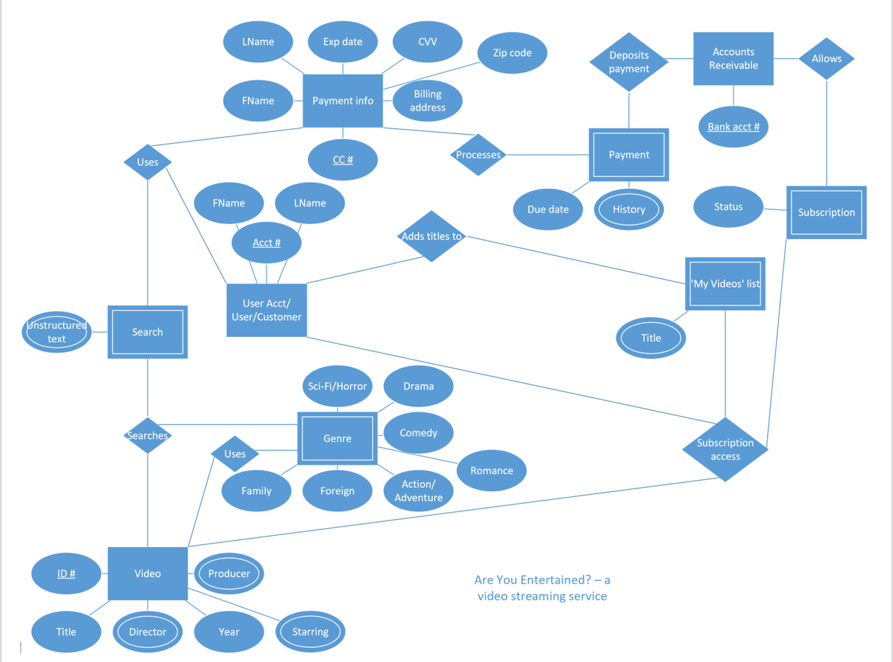

**4. EER Diagram**

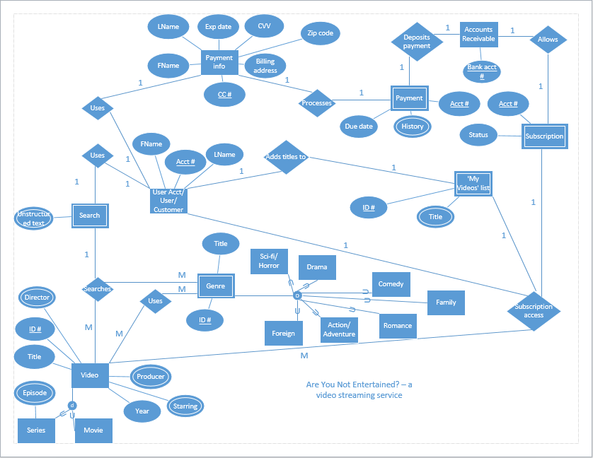

**5.** A description of your actual database tables, attributes and relationships.

**User Acct/User/Customer** – Holds the account holder’s name and acct#. Connected to Payment info, Video, ‘My Videos’ list, and Search.

**Payment info** – Holds all billing information. Connected to User Acct/User/Customer and Payment.

**Payment** – Holds Due date and History. Connected to Payment info and Accounts Receivable.

**Accounts Receivable** – Holds company’s bank acct info to receive payments. Connected to Payment and Subscription.

**Subscription** – Holds Acct# and Status for access to videos. Connected to Accounts Receivable, ‘My Videos’ list, User Acct/User/Customer, and Video.

**‘My Videos’ list** – Holds a list of videos the customer wants to see. Connected to Subscription, User Acct/User/Customer, and Video.

**Video** – Holds all information on videos from Title to Year and divides them into Movies and Series. Connected to Search, Genre, Subscription, User Acct/User/Customer, and ‘My Videos’ list.

**Genre** – Holds identifying info on videos and categorizes them into genres. Connected to Search and Video.

**6.** Snapshots of your created database and each table.

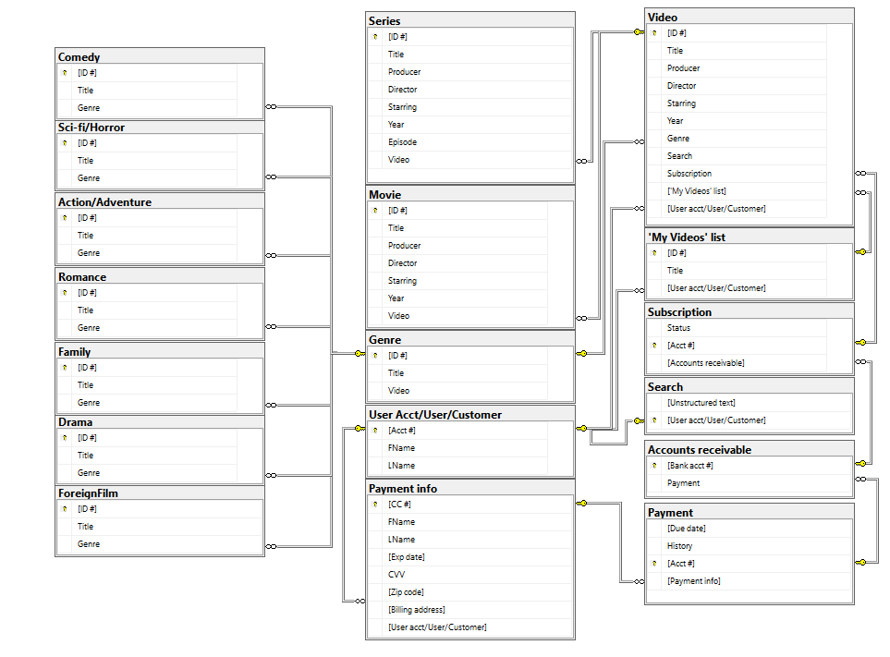

**7.** Snapshots of the queries that you have executed and the execution results.

1. Table – User acct#/User/Customer

Insert 3 rows

Insert Into [User Acct/User/Customer] ([Acct #], FName, LName)

Values (‘1’, ‘Paul’, ‘Polsinelli’), (‘2’, ‘Minet’, ‘Polsinelli’), (‘3’, ‘Aurora’, ‘Polsinelli’)

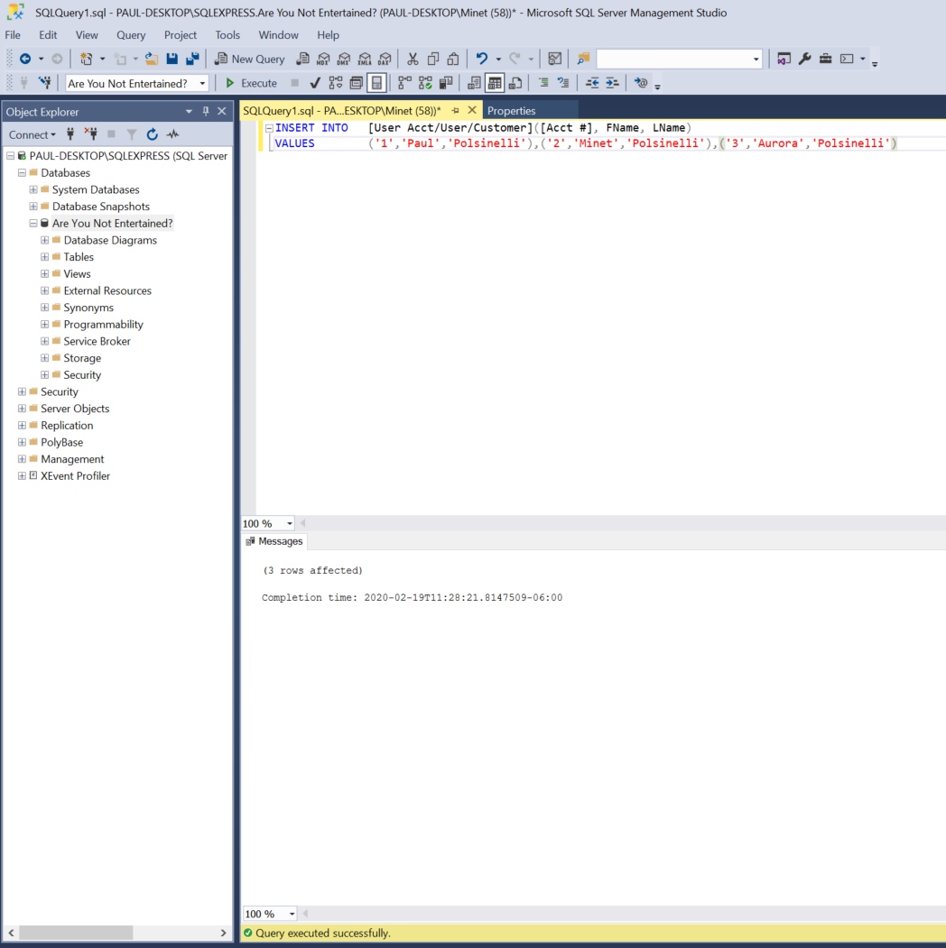

Insert 3 rows result

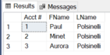

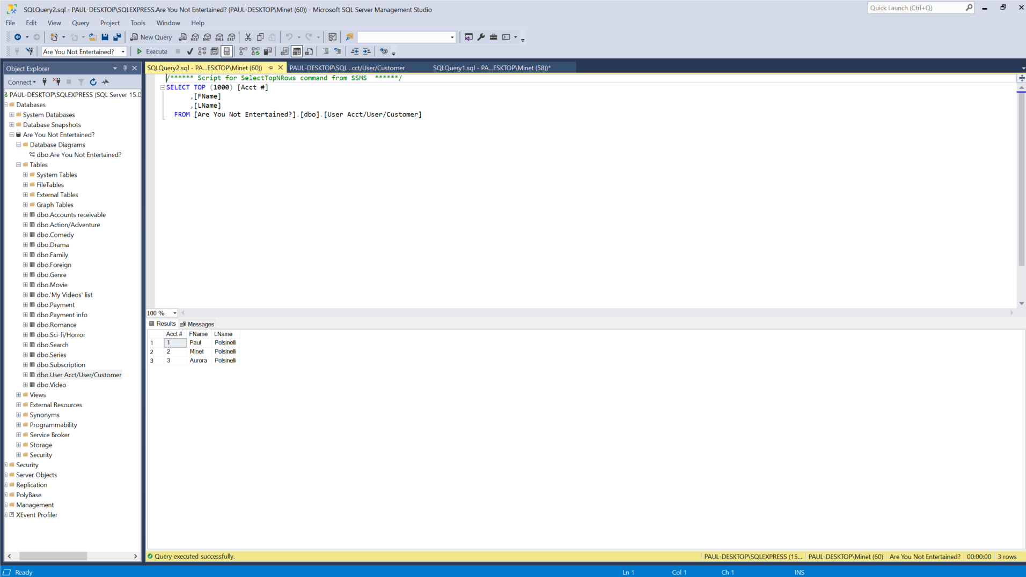

Update 1 row

Update [User Acct/User/Customer]

Set LName = ‘Mucka-Polsinelli’

Where [Acct #] = ‘2’

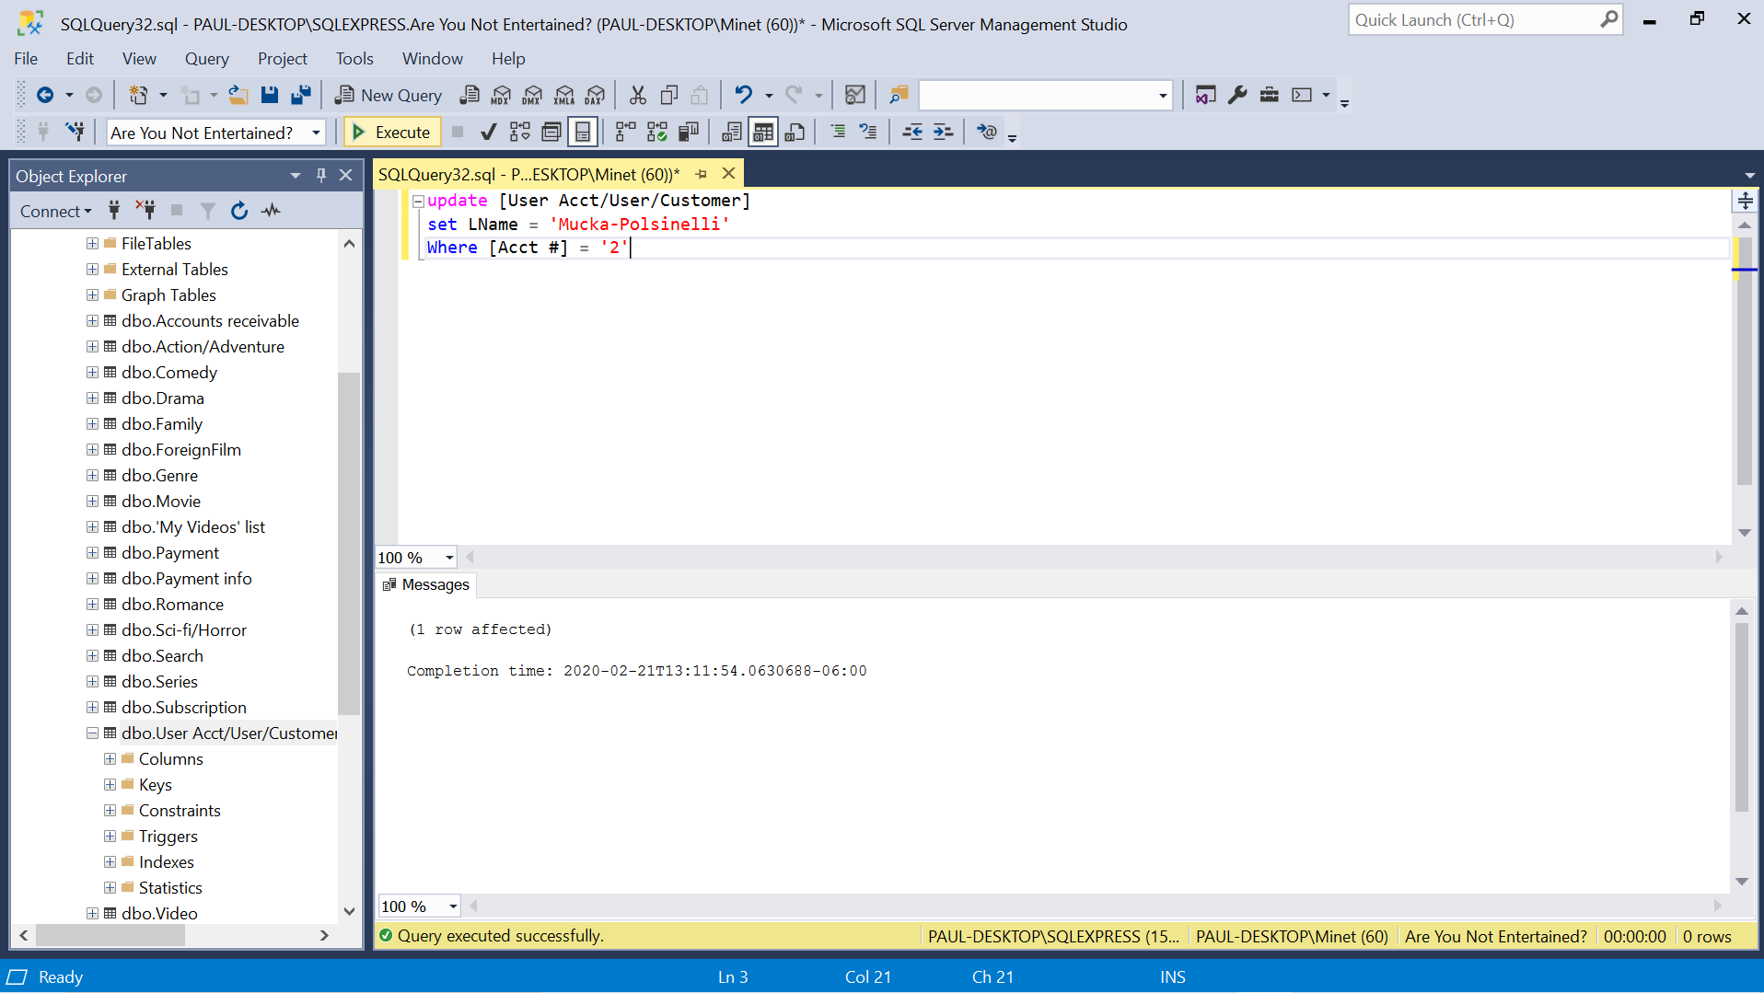

Update 1 row result

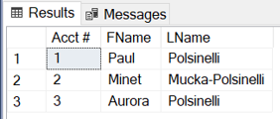

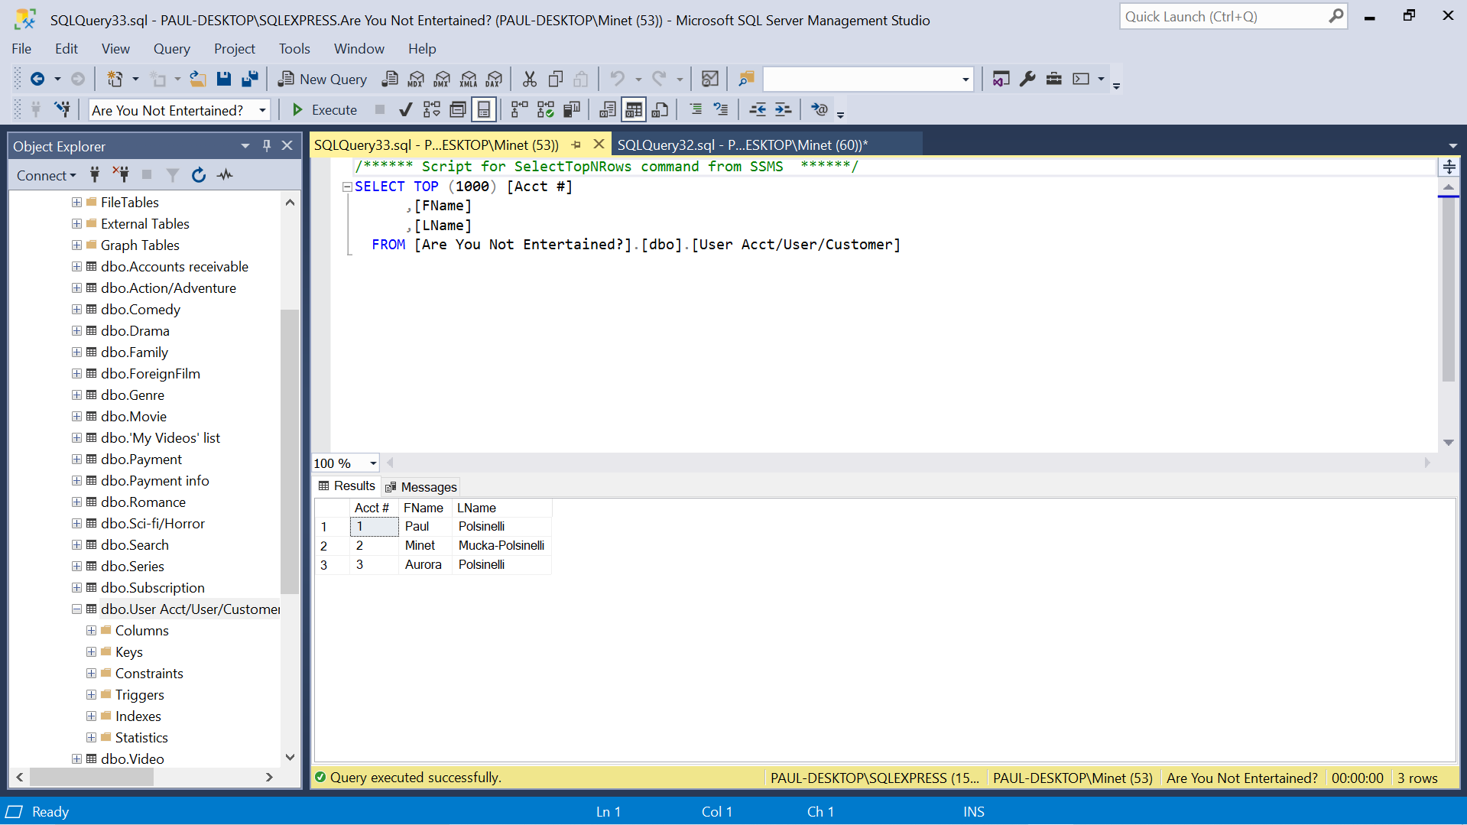

1. Table – Payment info

Insert 3 rows

Insert into [Payment info] ([CC #], FName, LName, [Exp date], CVV, [Billing address], [Zip code])

Values (‘1234567890123456’, ‘Paul’, ‘Polsinelli’, ‘10/03/1973’, ‘123’, ‘2704 Greywood ln. Plano, TX’, ‘75075’), (‘2345678901234567’, ‘Minet’, ‘Polsinelli’, ‘02/10/1980’, ‘234’, ‘2704 Greywood ln. Plano, TX’, ‘75075’), (‘3456789012345678’, ‘Aurora’, ‘Polsinelli’, ‘05/01/2012’, ‘123’, ‘2704 Greywood ln. Plano, TX’, ‘75075’),

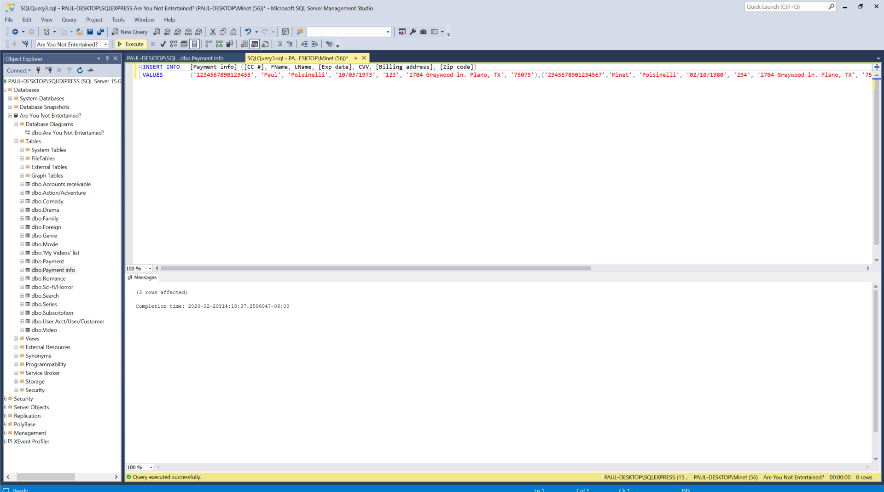

Insert 3 rows result

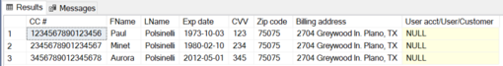

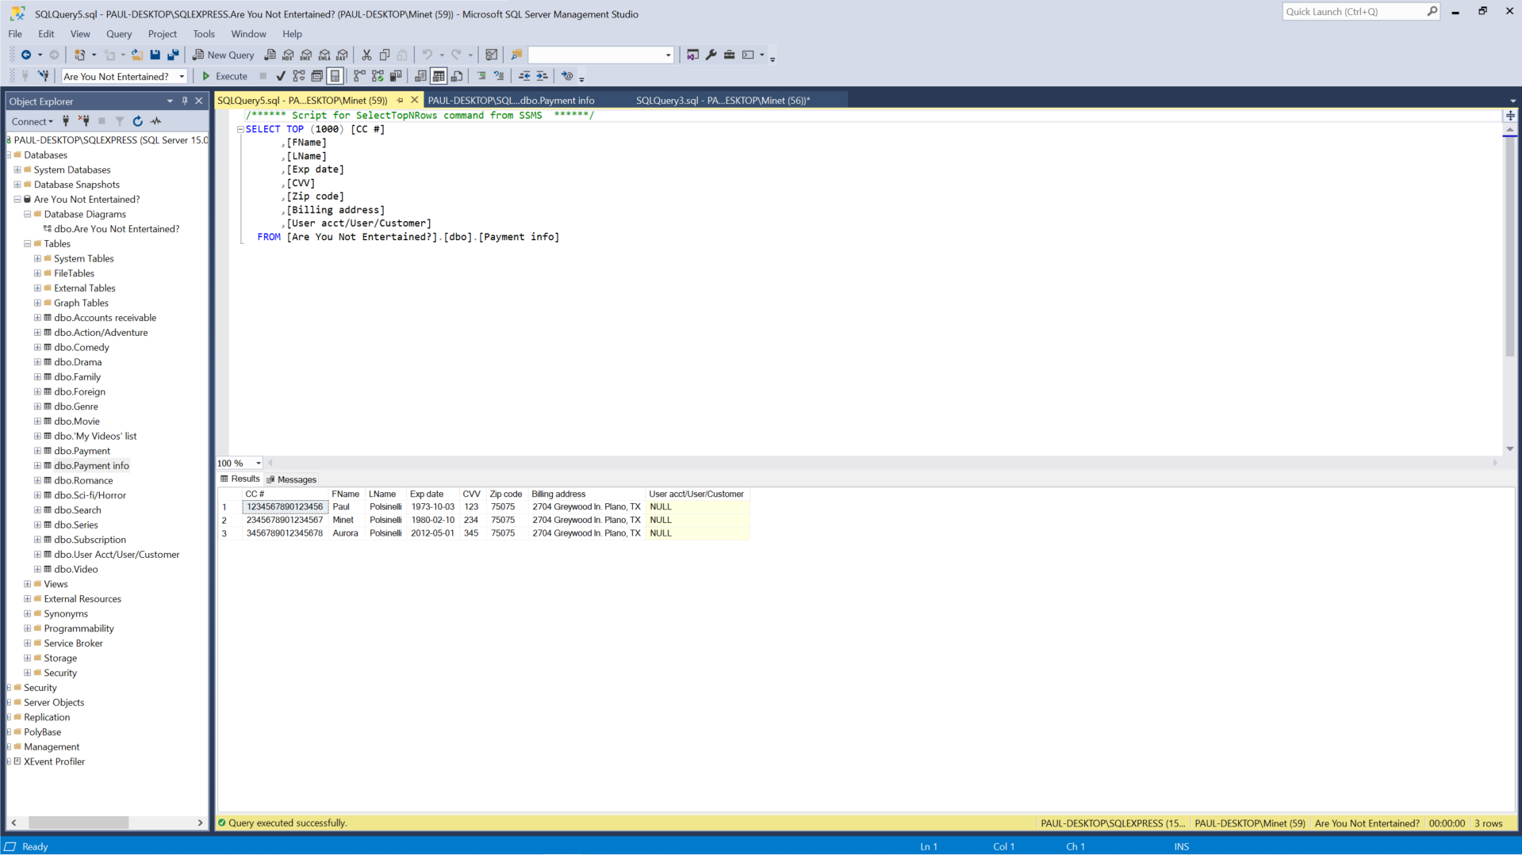

Update 1 row

Update [Payment info]

Set CVV = ‘333’

Where FName = ‘Paul’

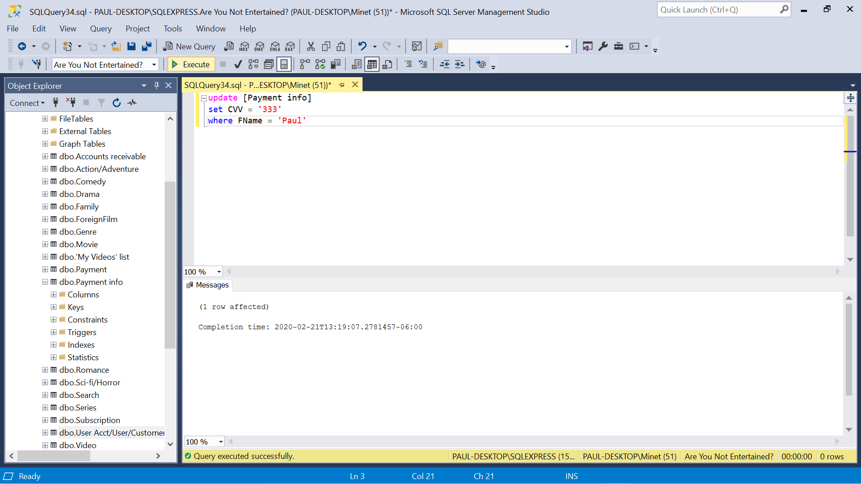

Update 1 row result

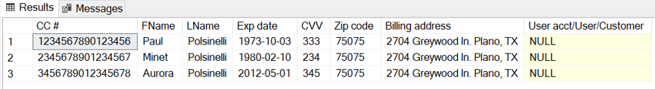

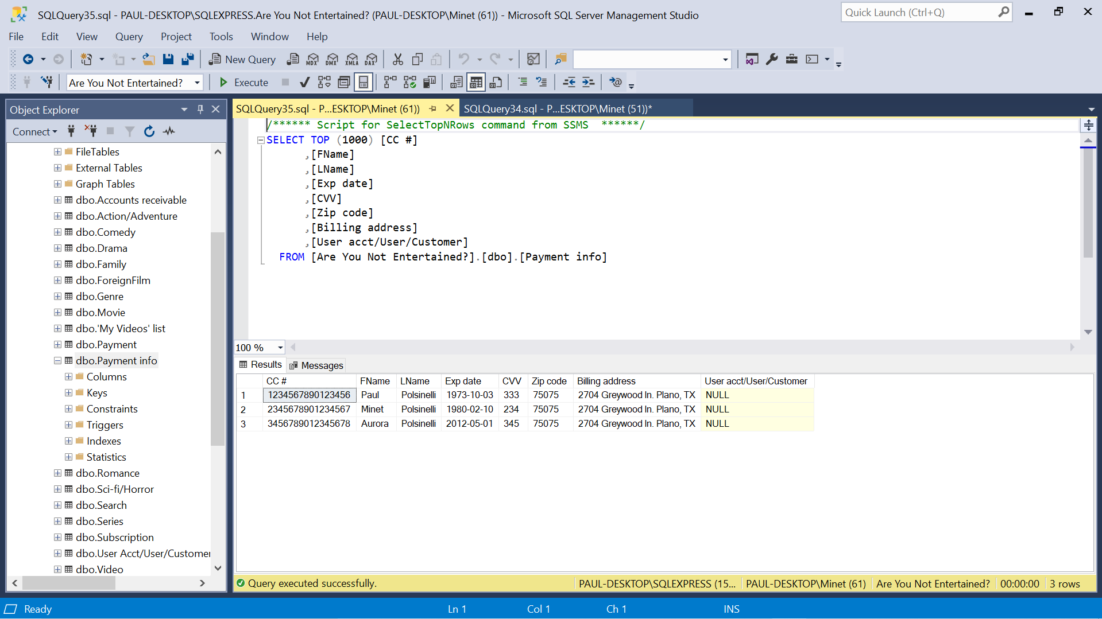

1. Table – Payment

Insert 3 rows

insert into Payment ([Acct #], [Due date], History)

values (‘1’, ‘03/01/20’, ‘’), (‘2’, ‘03/01/20’, ‘’), (‘3’, ‘03/01/20’, ‘’)

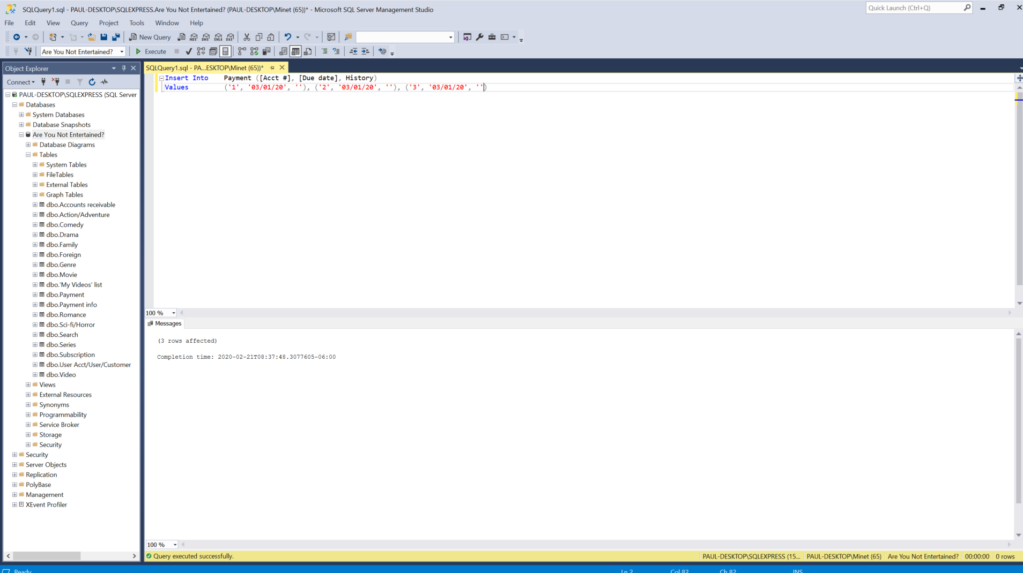

Insert 3 rows result

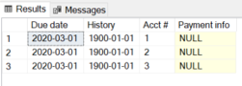

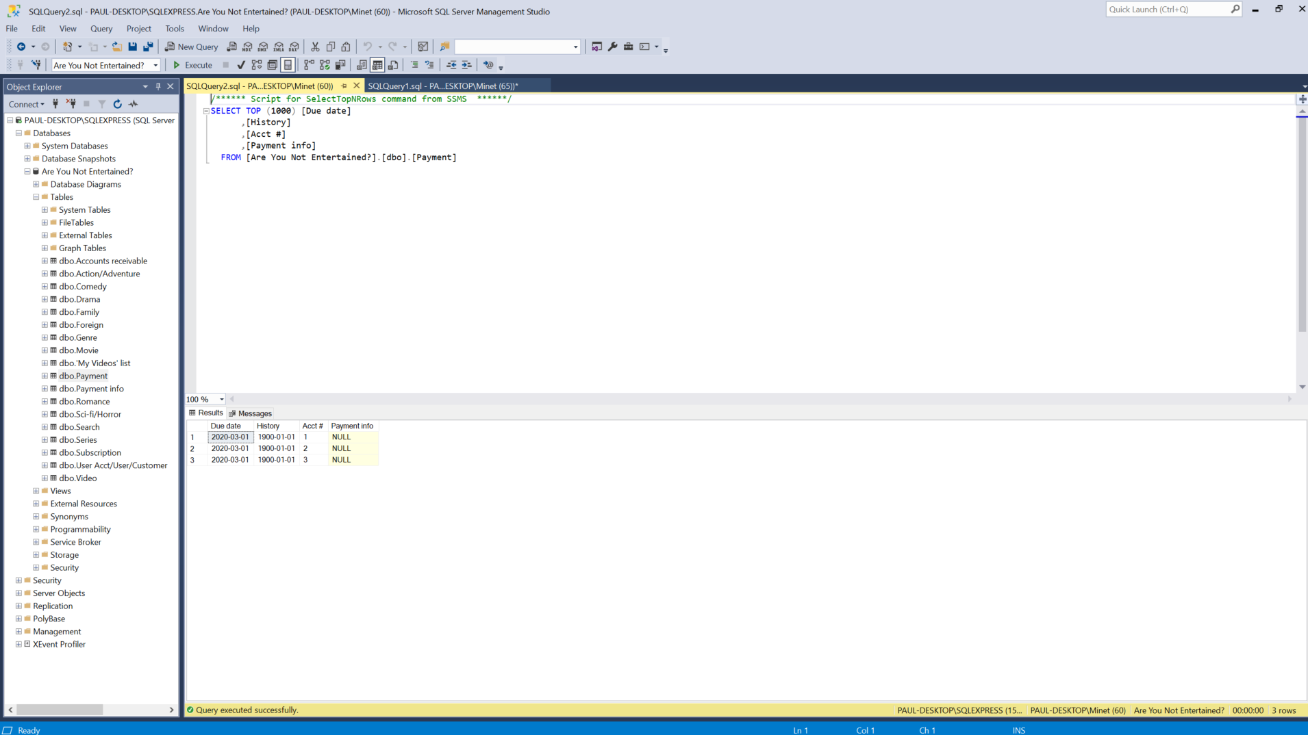

Update 1 row

Update Payment

Set [Due date] = ‘03/15/20’

Where [Acct #] = ‘2’

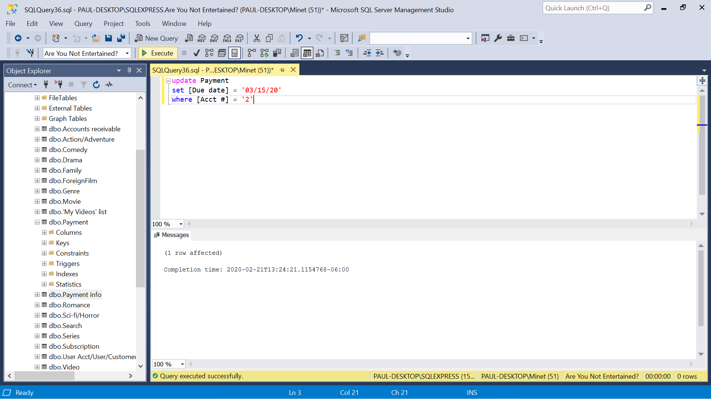

Update 1 row result

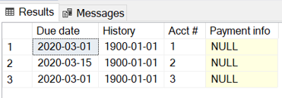

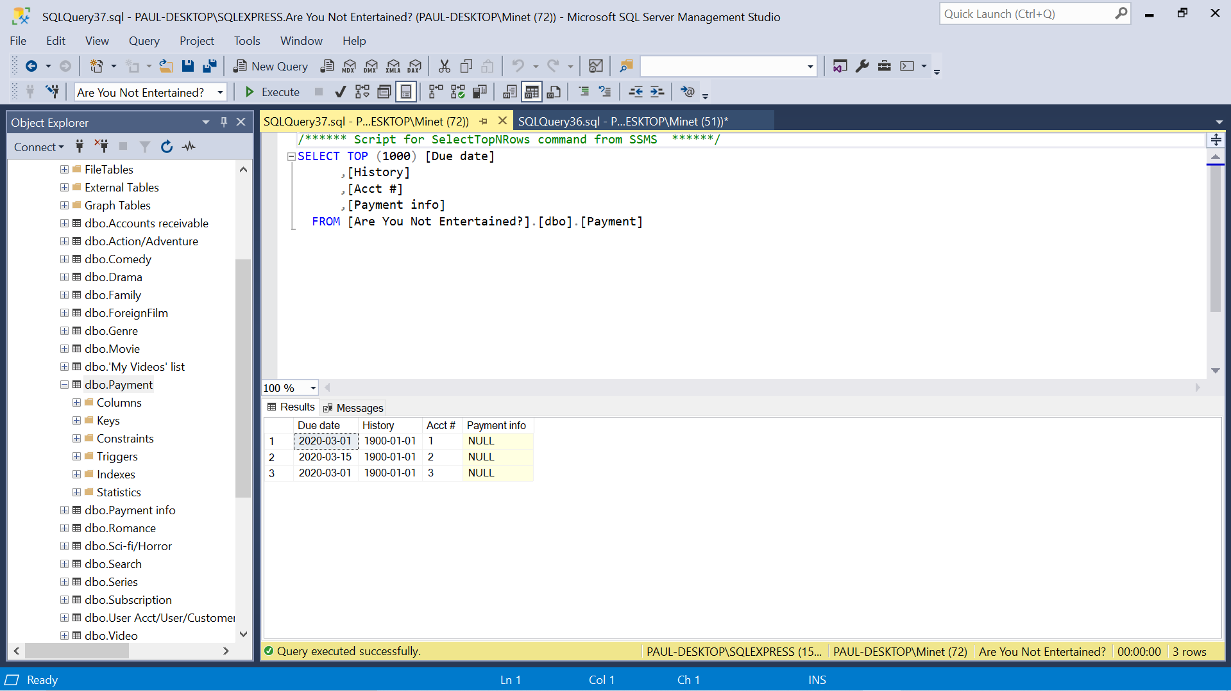

1. Table – Accounts receivable

Insert 3 rows

Insert into [Accounts receivable] (]Bank acct #])

Values (111111111), (222222222), (333333333)

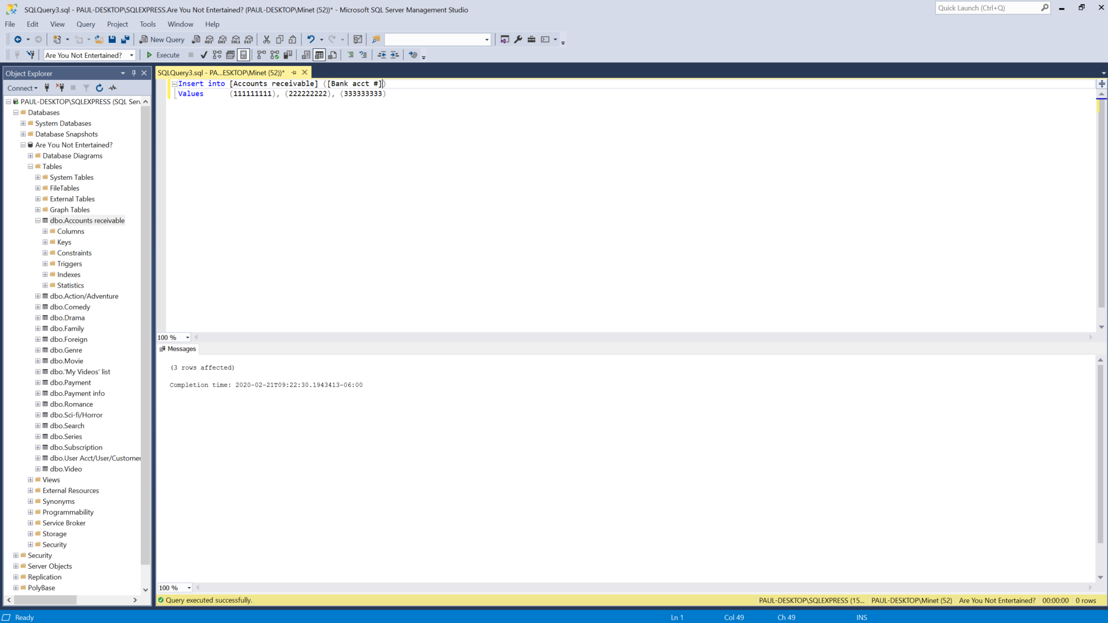

Insert 3 rows result

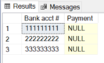

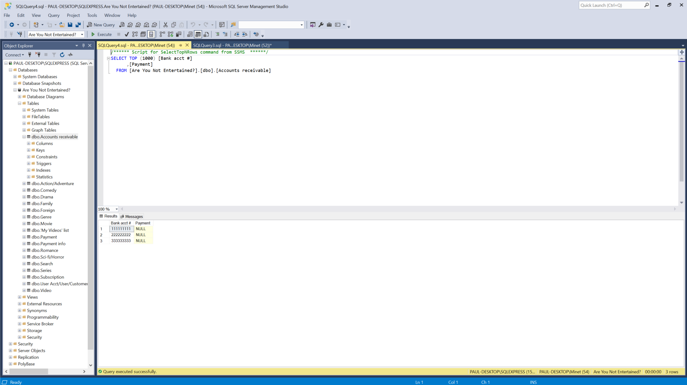

Update 1 row

Update [Accounts receivable]

Set [Bank acct #] = ‘333333331’

Where [Bank acct #] = ‘333333333’

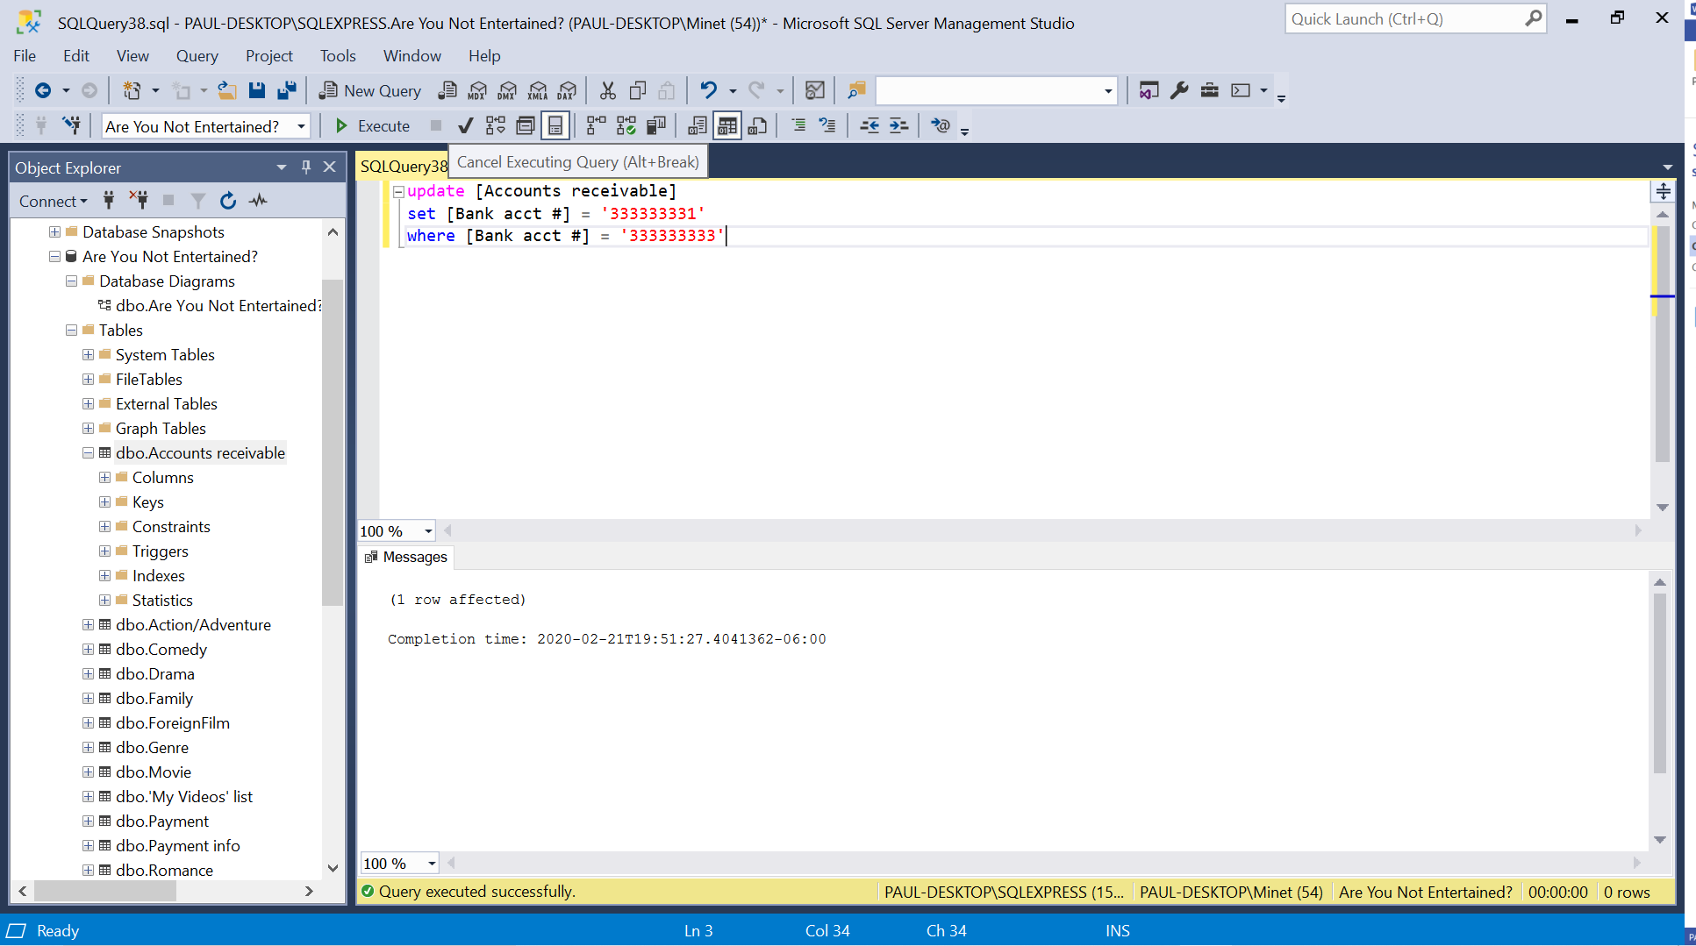

Update 1 row results

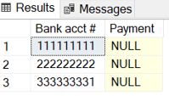

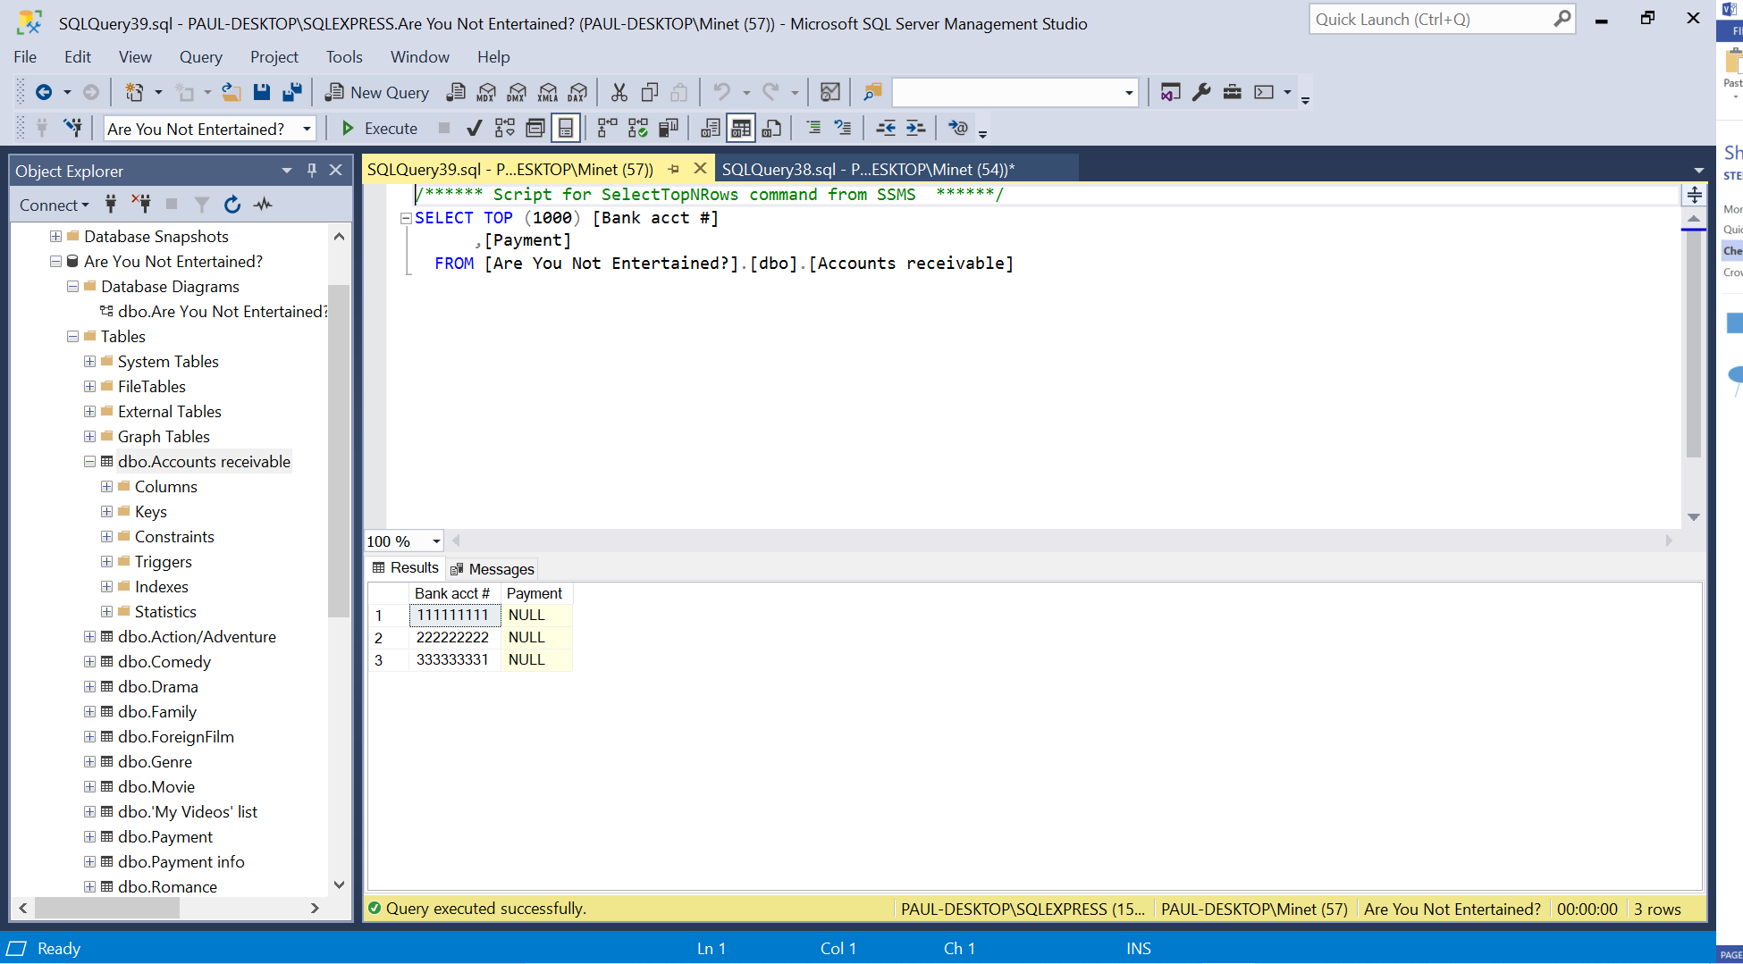

1. Table – Subscription

Insert 3 rows

Insert into Subscription ([Acct #], Status)

Values(‘1’, ‘Active’), (‘2’, ‘Active’), (‘3’, ‘Inactive’)

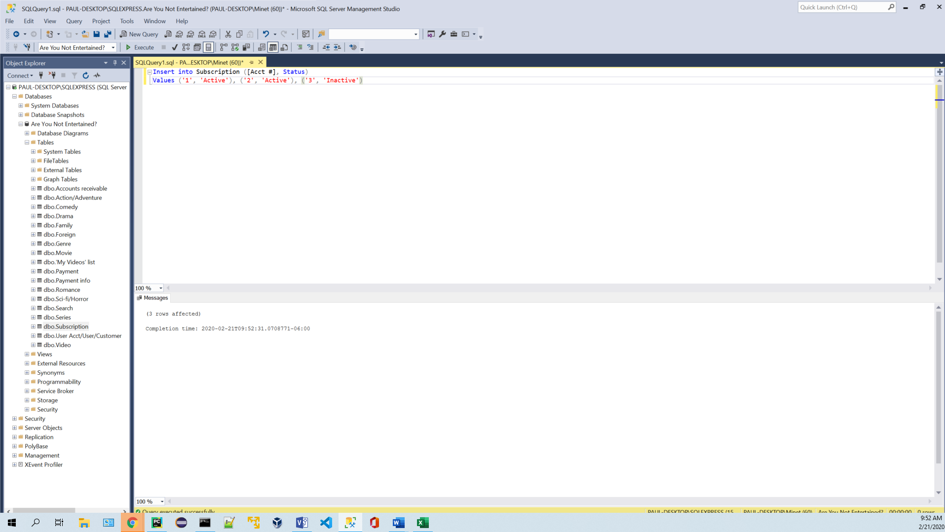

Insert 3 rows result

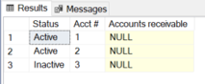

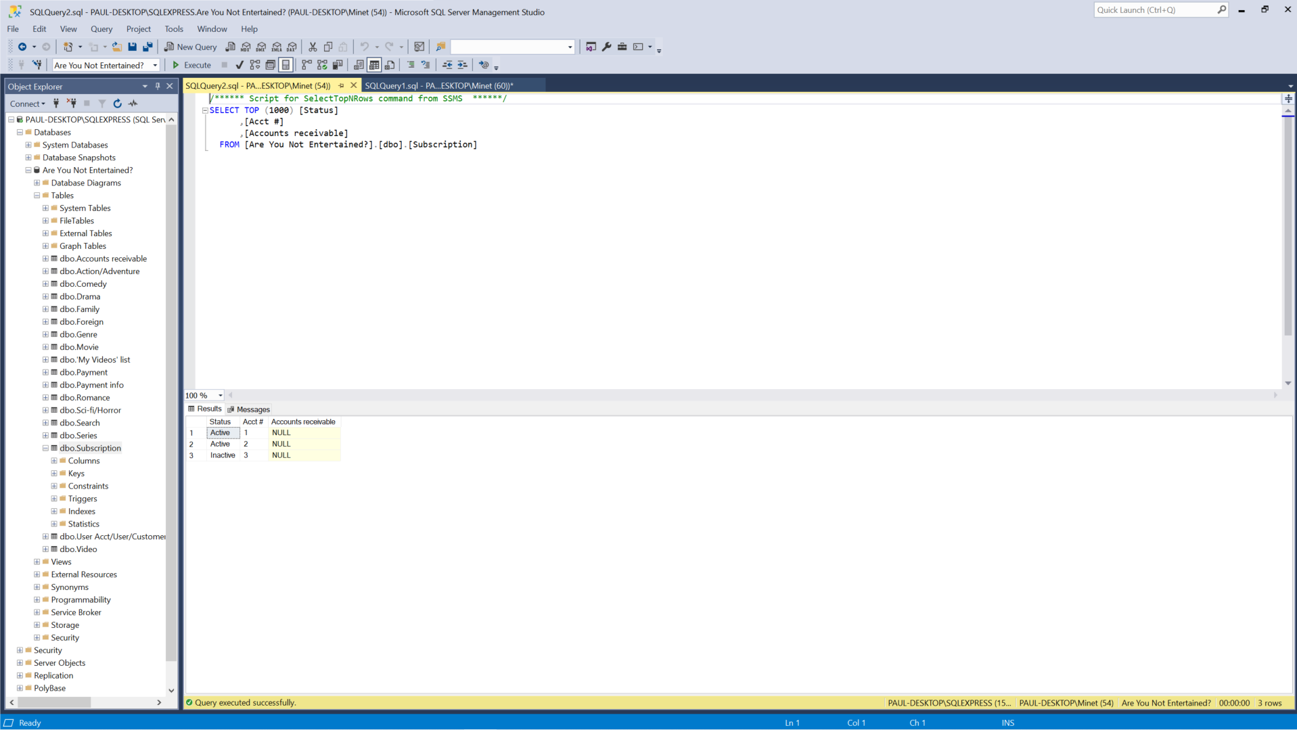

Update 1 row

Update Subscription

Set Status = ‘Inactive’

Where [Acct #] = ‘2’

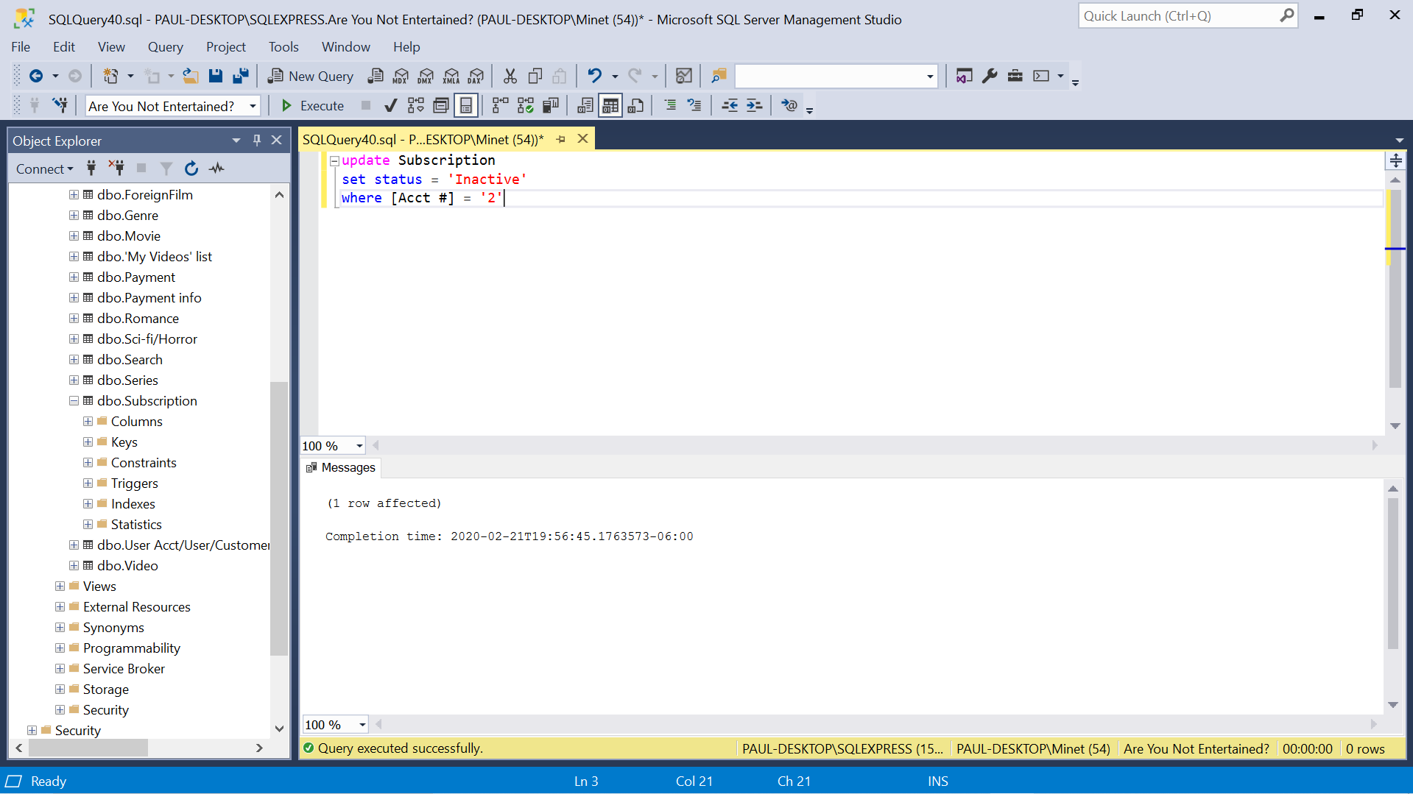

Update 1 row result

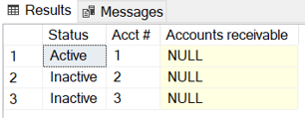

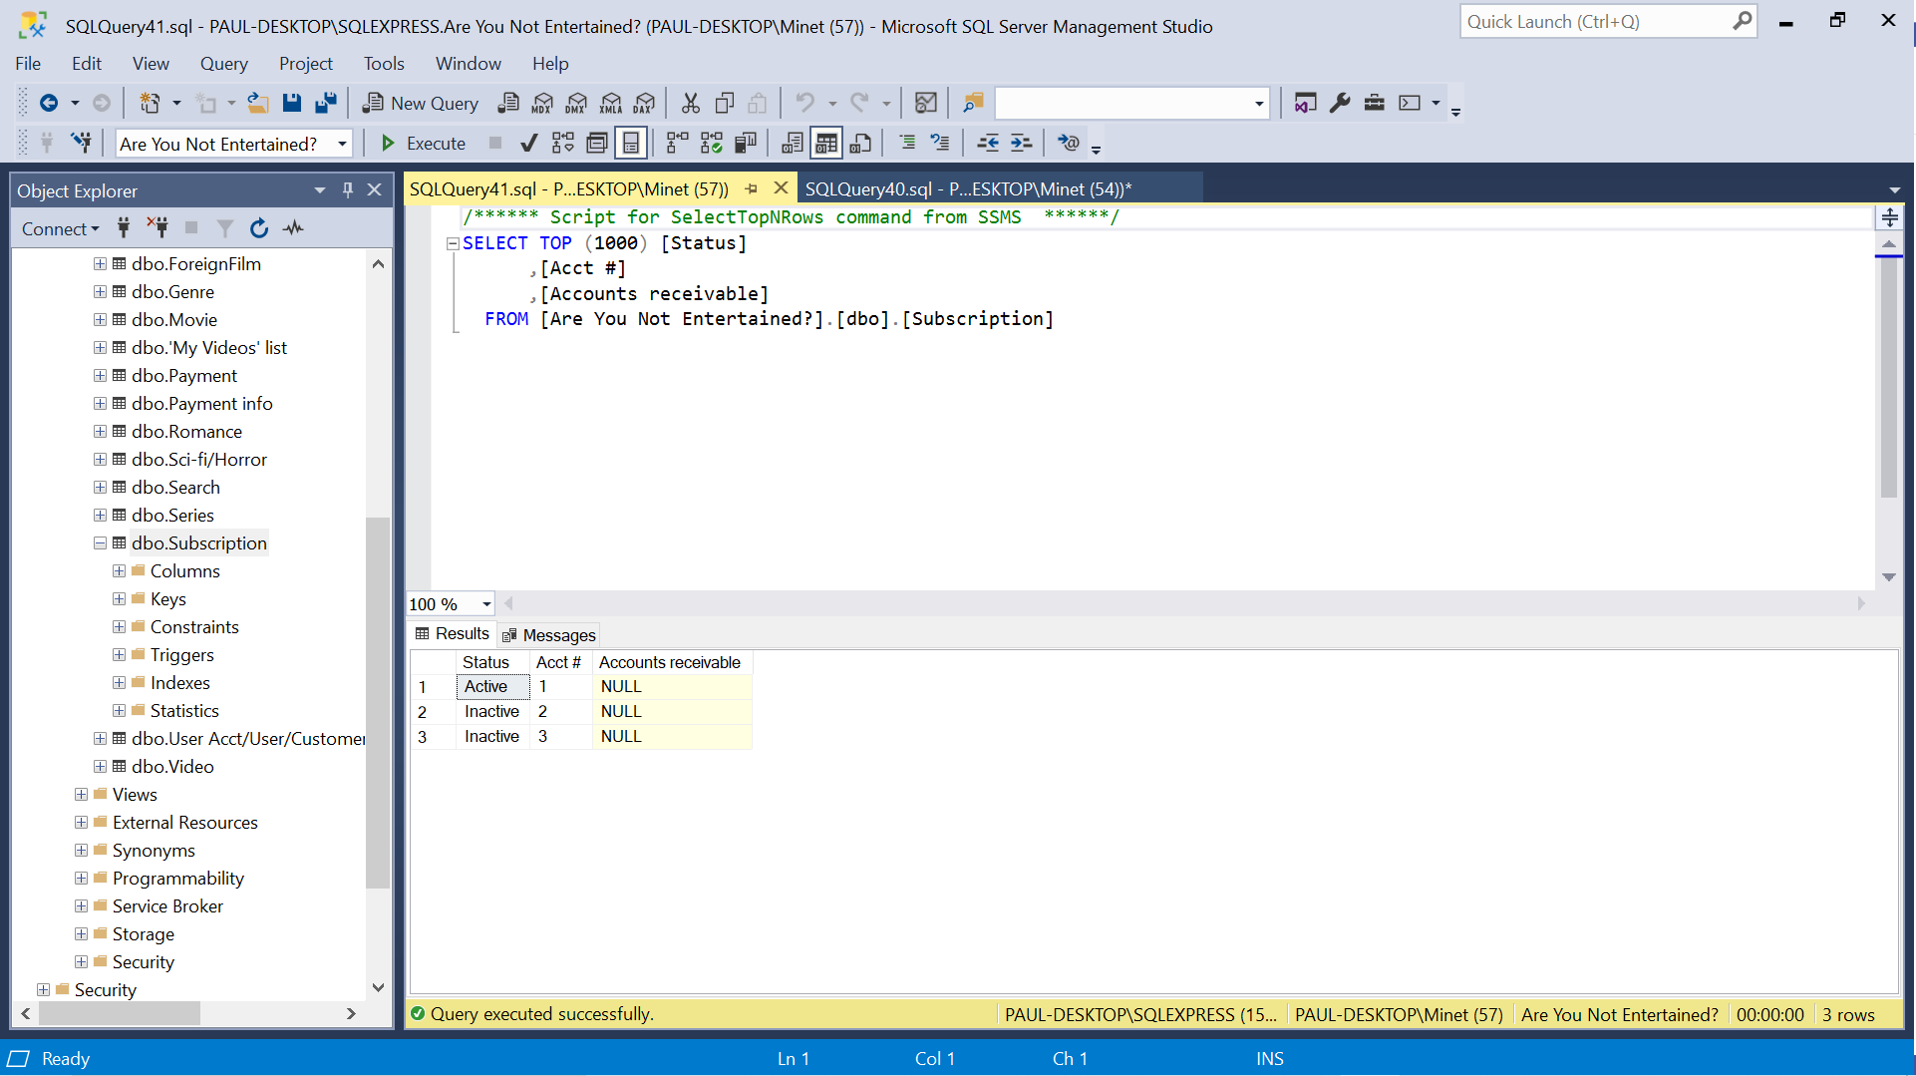

1. Table – ‘My Videos’ list

Insert 3 rows

Insert into [‘My Videos’ list] ([ID #], Title)

Values (‘0000000001’, ‘Roundhay Garden Scene’), (‘0000000002’, ‘Dickson Greeting’), (‘0000000003’, ‘Pantomimes Lumineuses’)

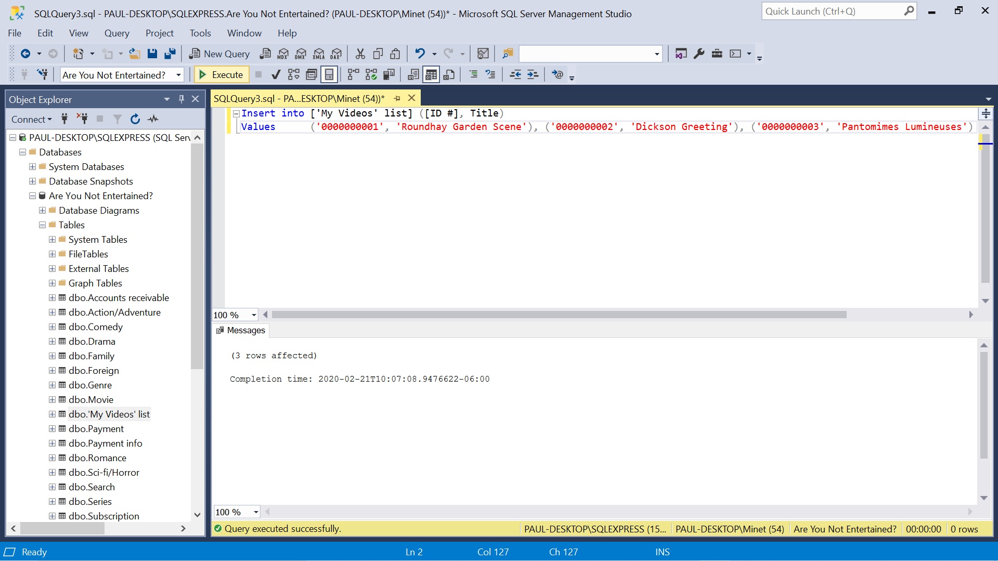

Insert 3 rows result

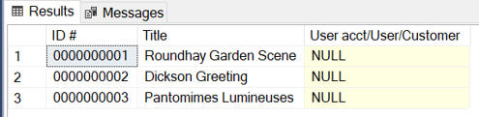

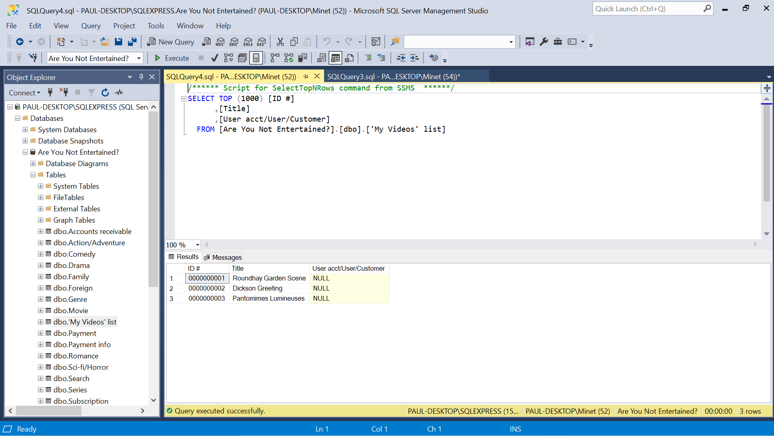

Update 1 row

Update [‘My Videos’ list]

Set Title = ‘Roundhay Garden Scene – original’

Where [ID #] = ‘0000000001’

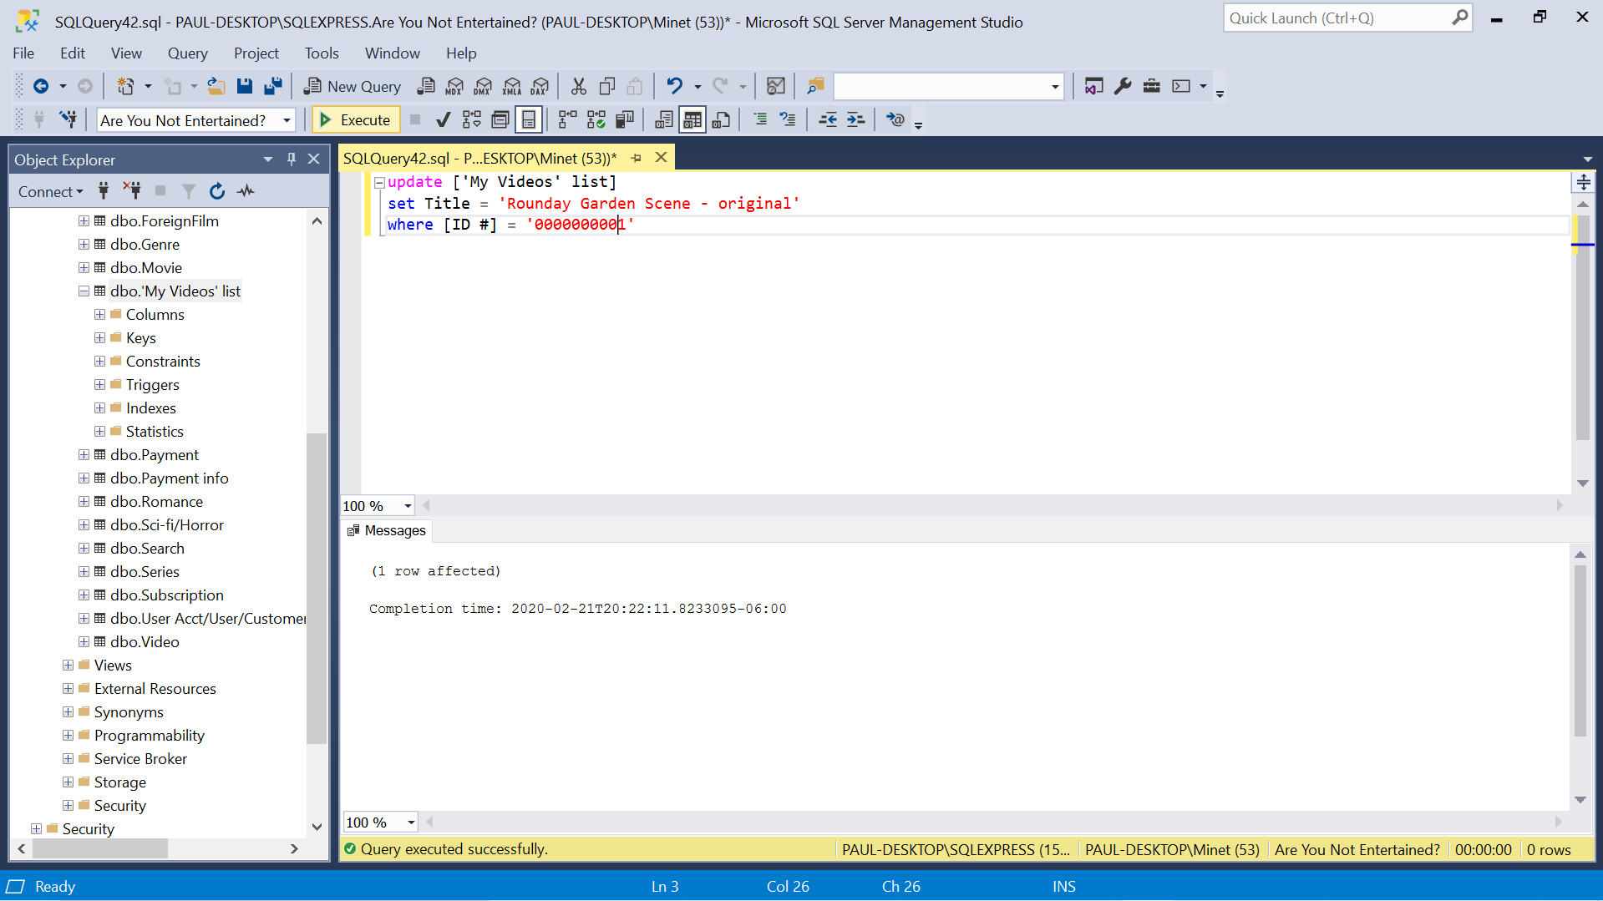

Update 1 row result

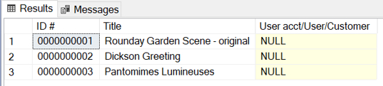

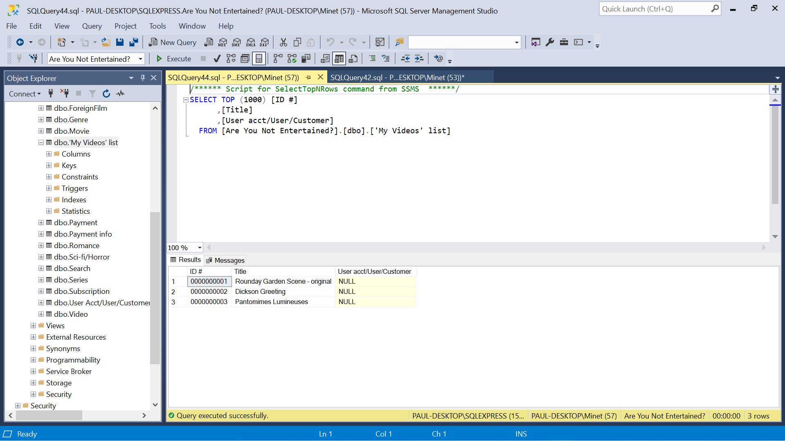

1. Table – Video Insert 3 rows

Insert into Video ([ID #], Title, Producer, Director, Starring, Year)

Values (‘0000000001’, ‘Roundhay Garden Scene’, ‘Louis Le Prince’, ‘Louis Le Prince’, ‘Annie Hartley’, ‘1888’), (‘0000000002’, ‘Dickson Greeting’, ‘William. K.L. Dickson’, ‘William. K.L. Dickson’, ‘William. K.L. Dickson’, ‘1891’), (‘0000000003’, ‘Pantomimes Lumineuses’, ‘Charles-Emile Renaud’, ‘Charles-Emile Renaud’, ‘N/A’, ‘1892)

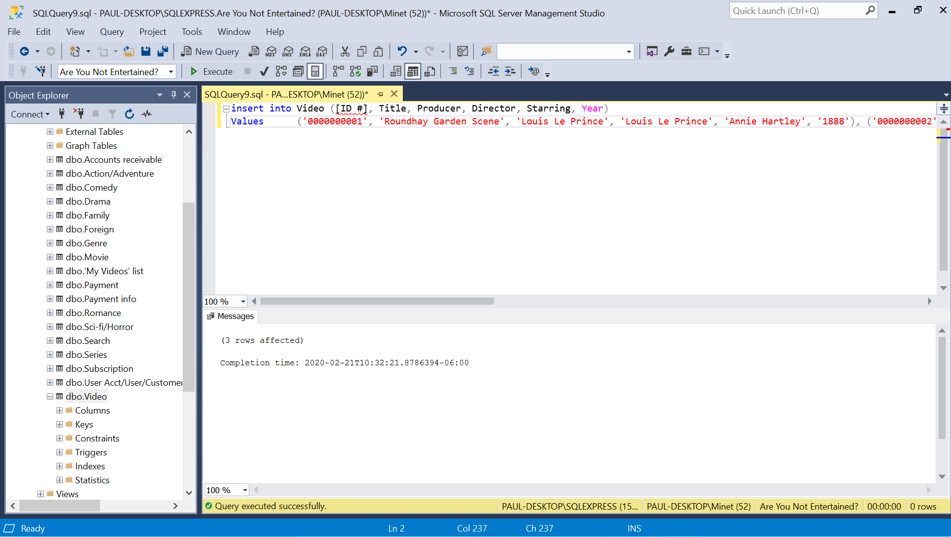

Insert 3 rows result



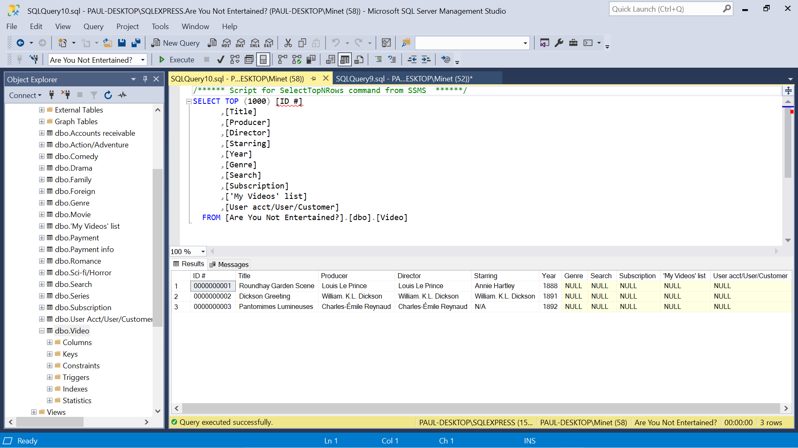

Update 1 row

Update Video

Set Year = ‘1887’

Where [ID #] = ‘0000000001’

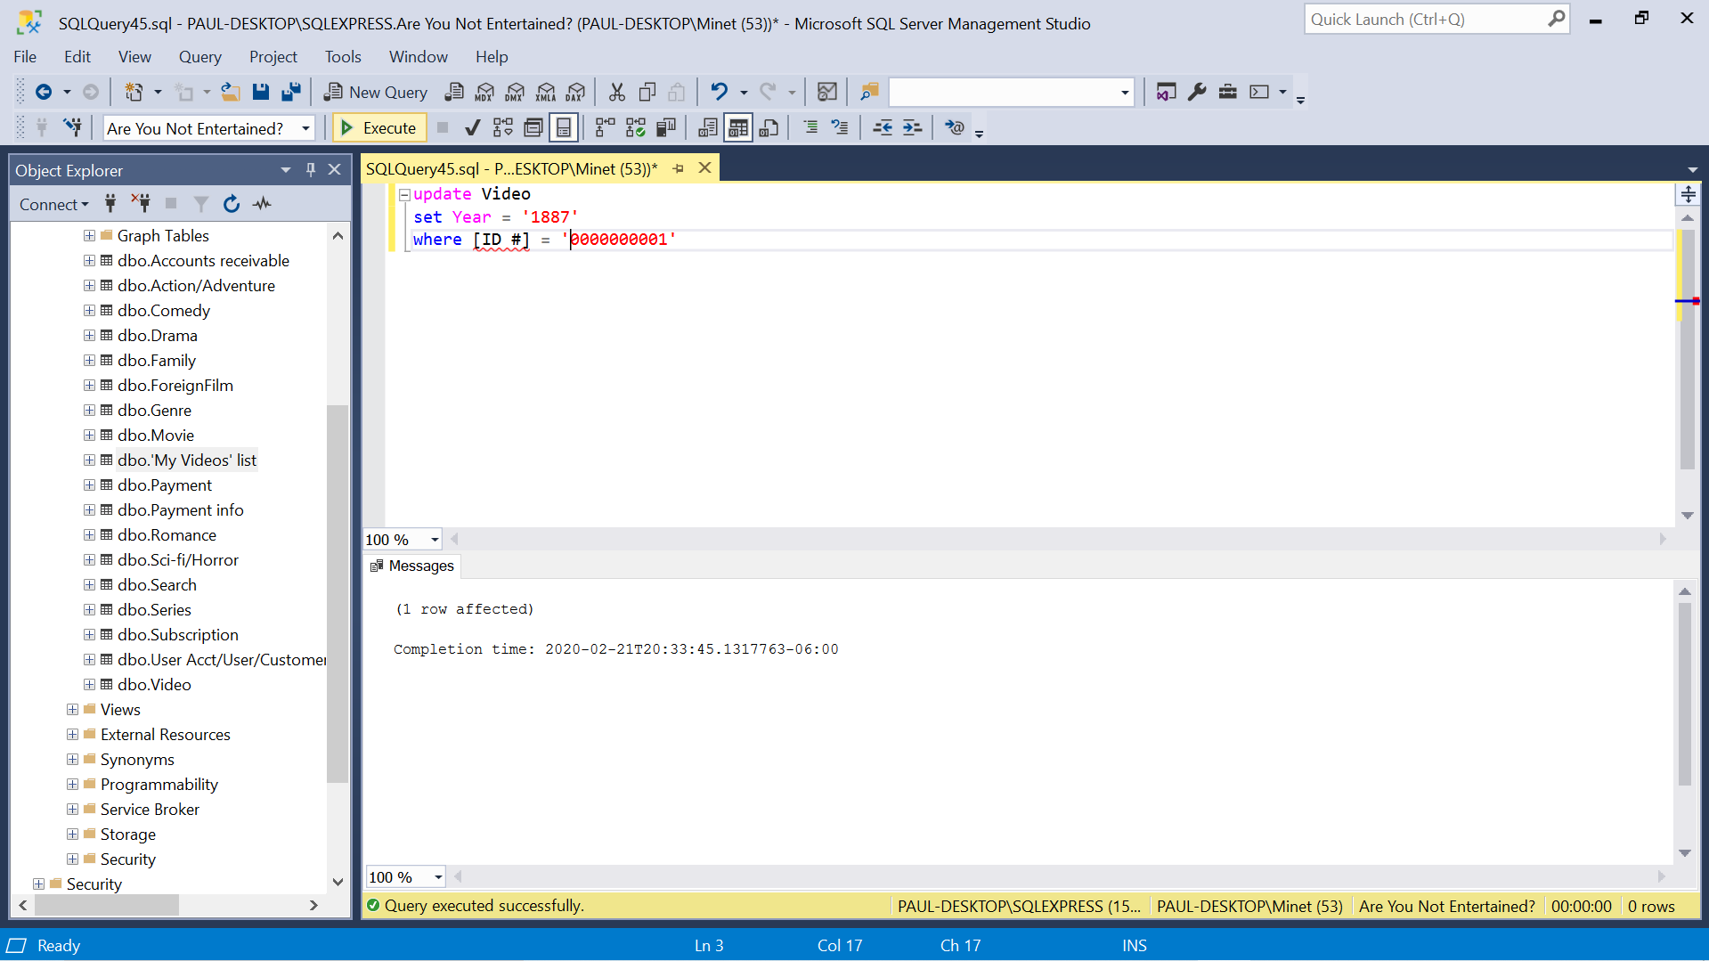

Update 1 row results



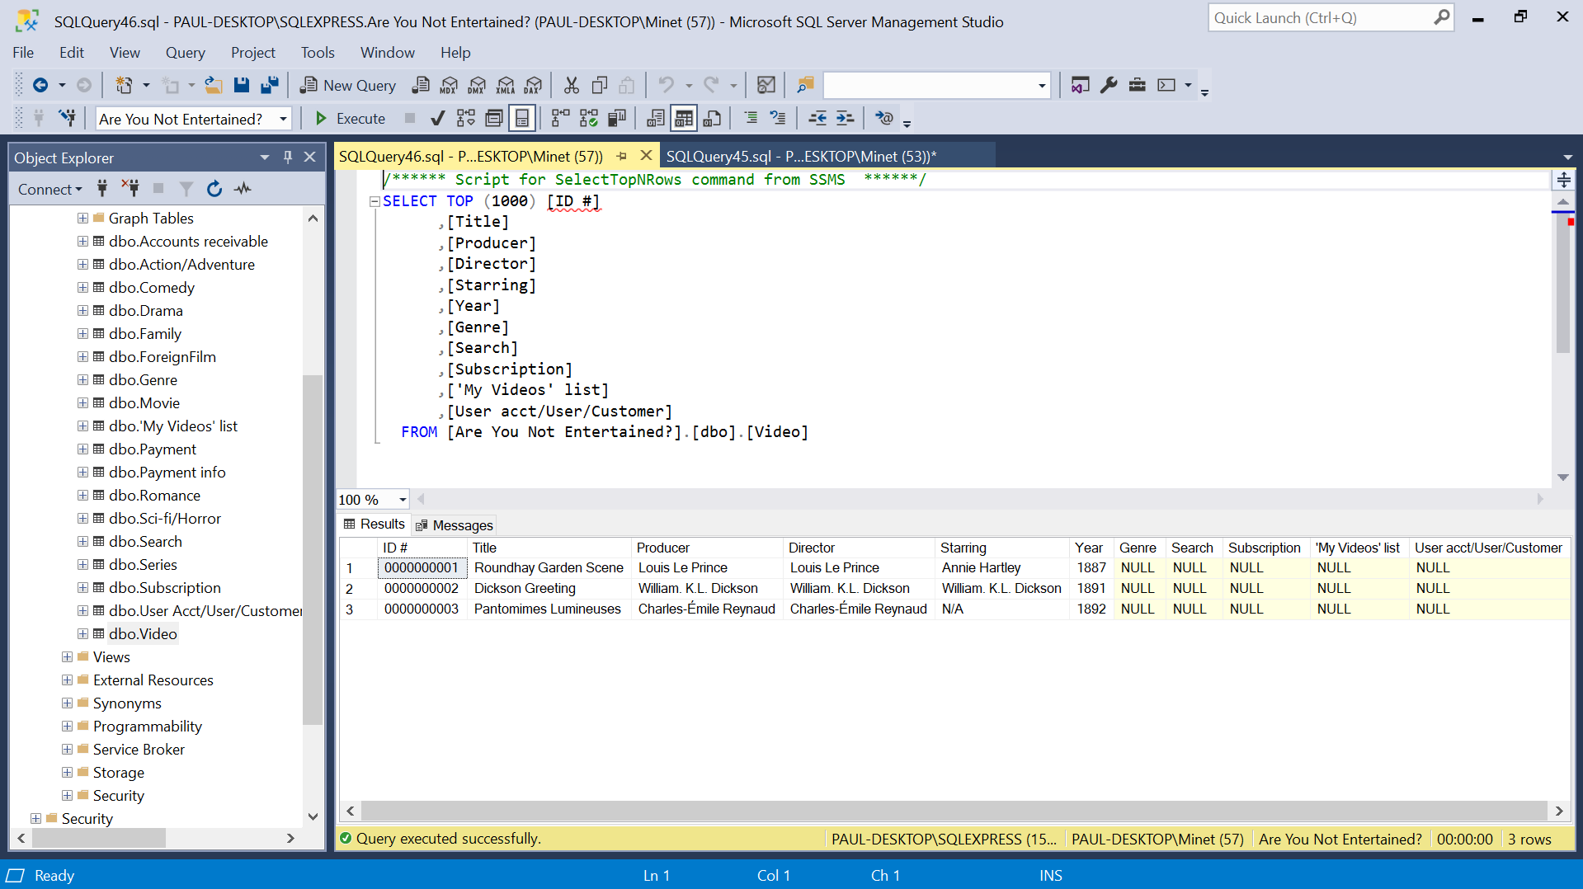

Retrieve an entire table (any table that I choose)

Select [ID #], Title, Producer, Director, Starring, Year

From Video

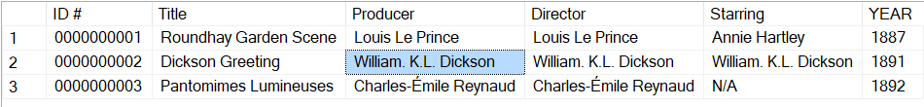

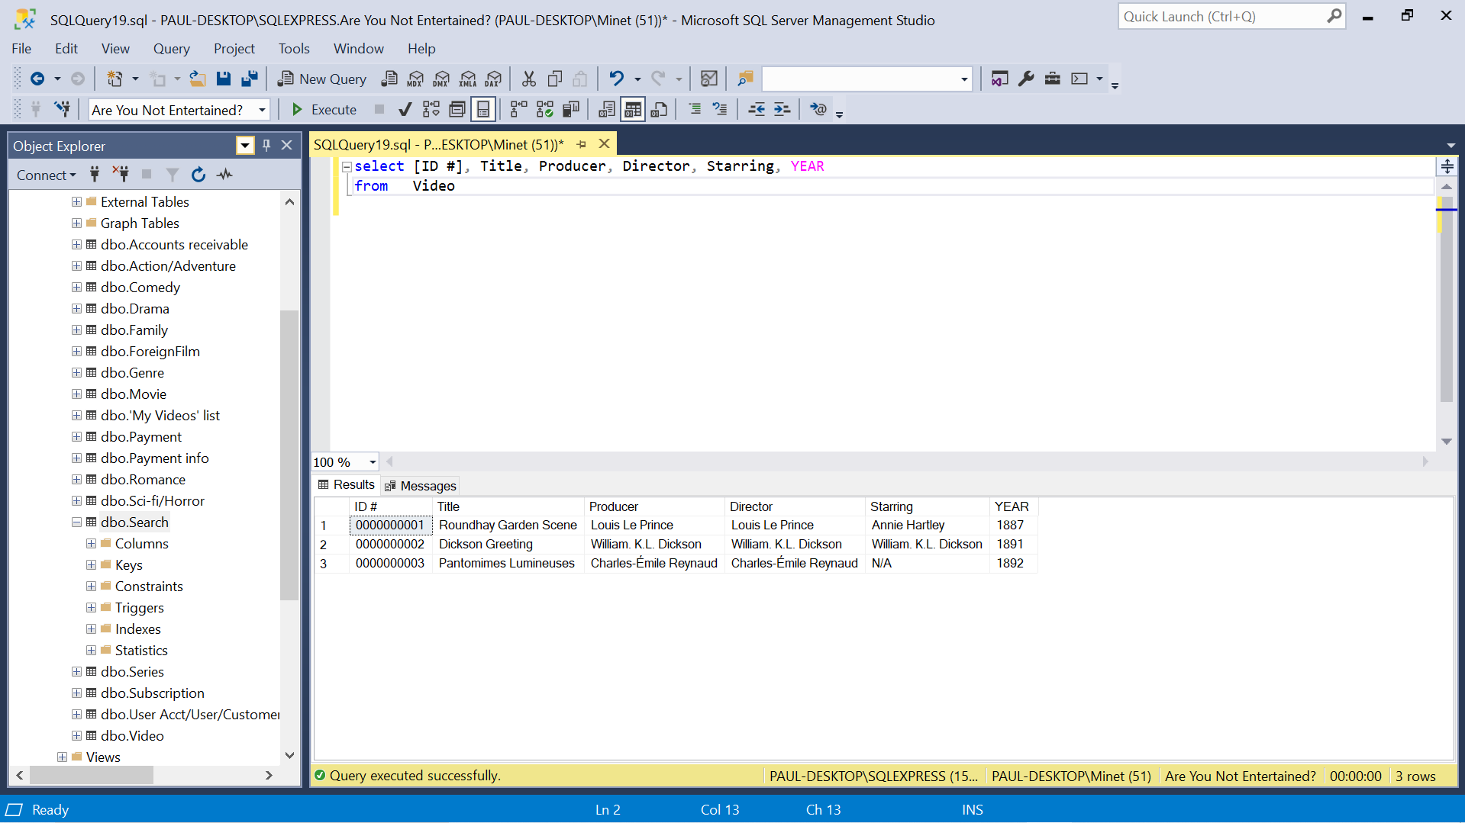

1. Table – Genre

Insert 3 rows

Insert into Genre ([ID#], Title)

Values (‘0000000001’, ‘Roundhay Garden Scene’), (‘0000000002’, ‘Dickson Greeting’), (‘0000000003’, ‘Pantomimes Lumineuses’)

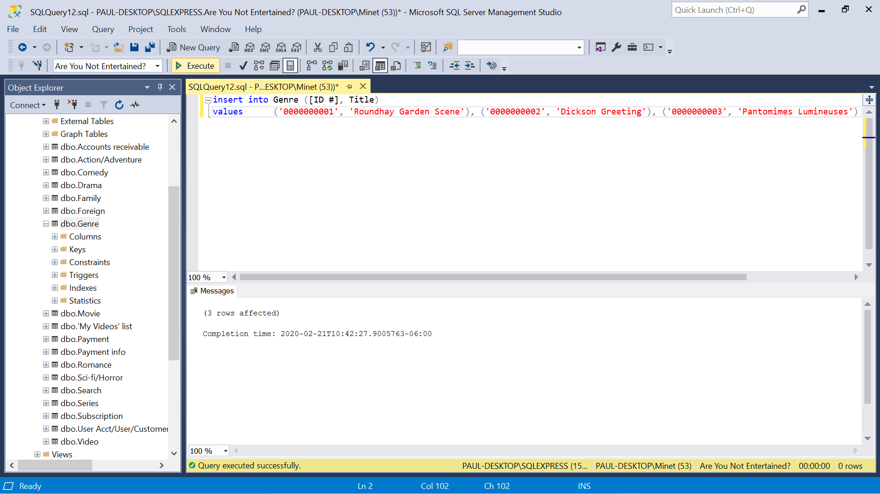

Insert 3 rows result

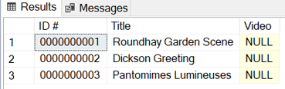

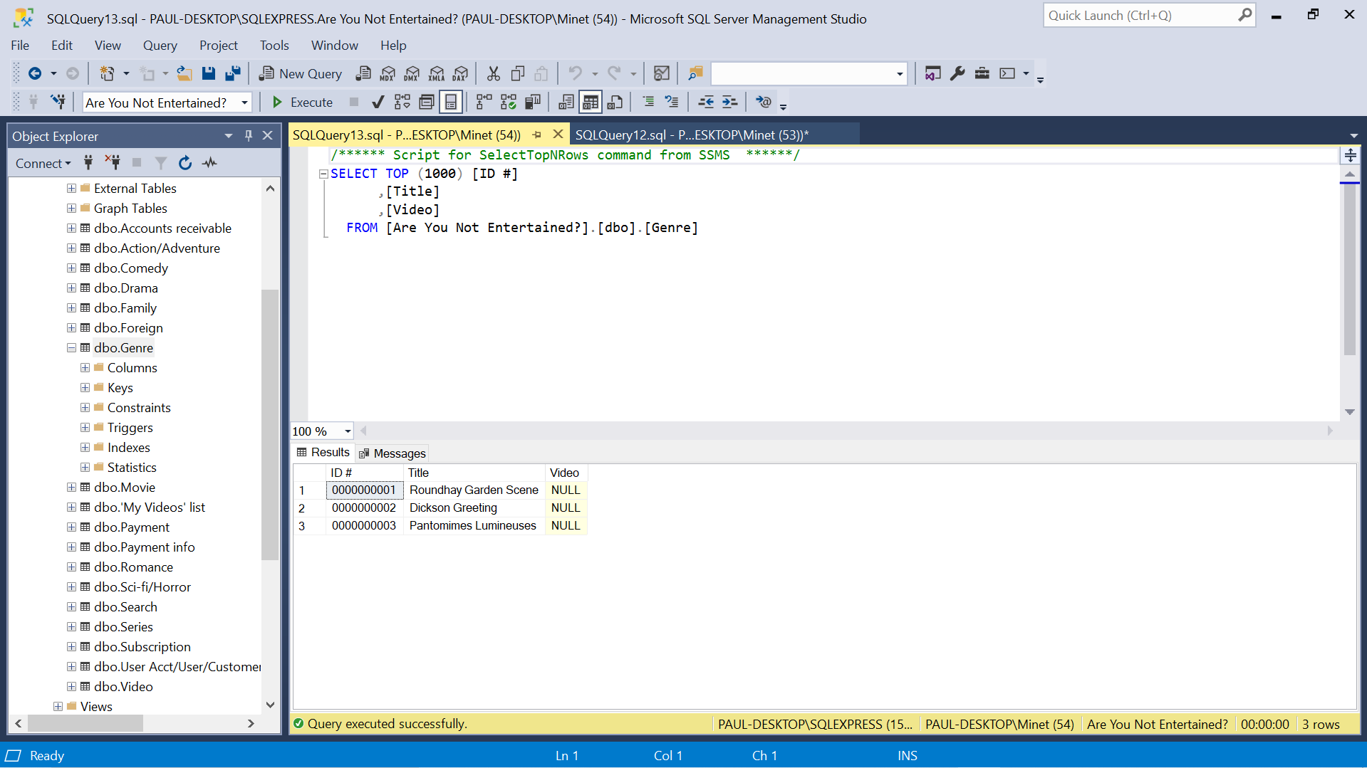

Update 1 row

Update Genre

Set [ID #] = ‘0000000000’

Where Title = ‘Roundhay Garden Scene’

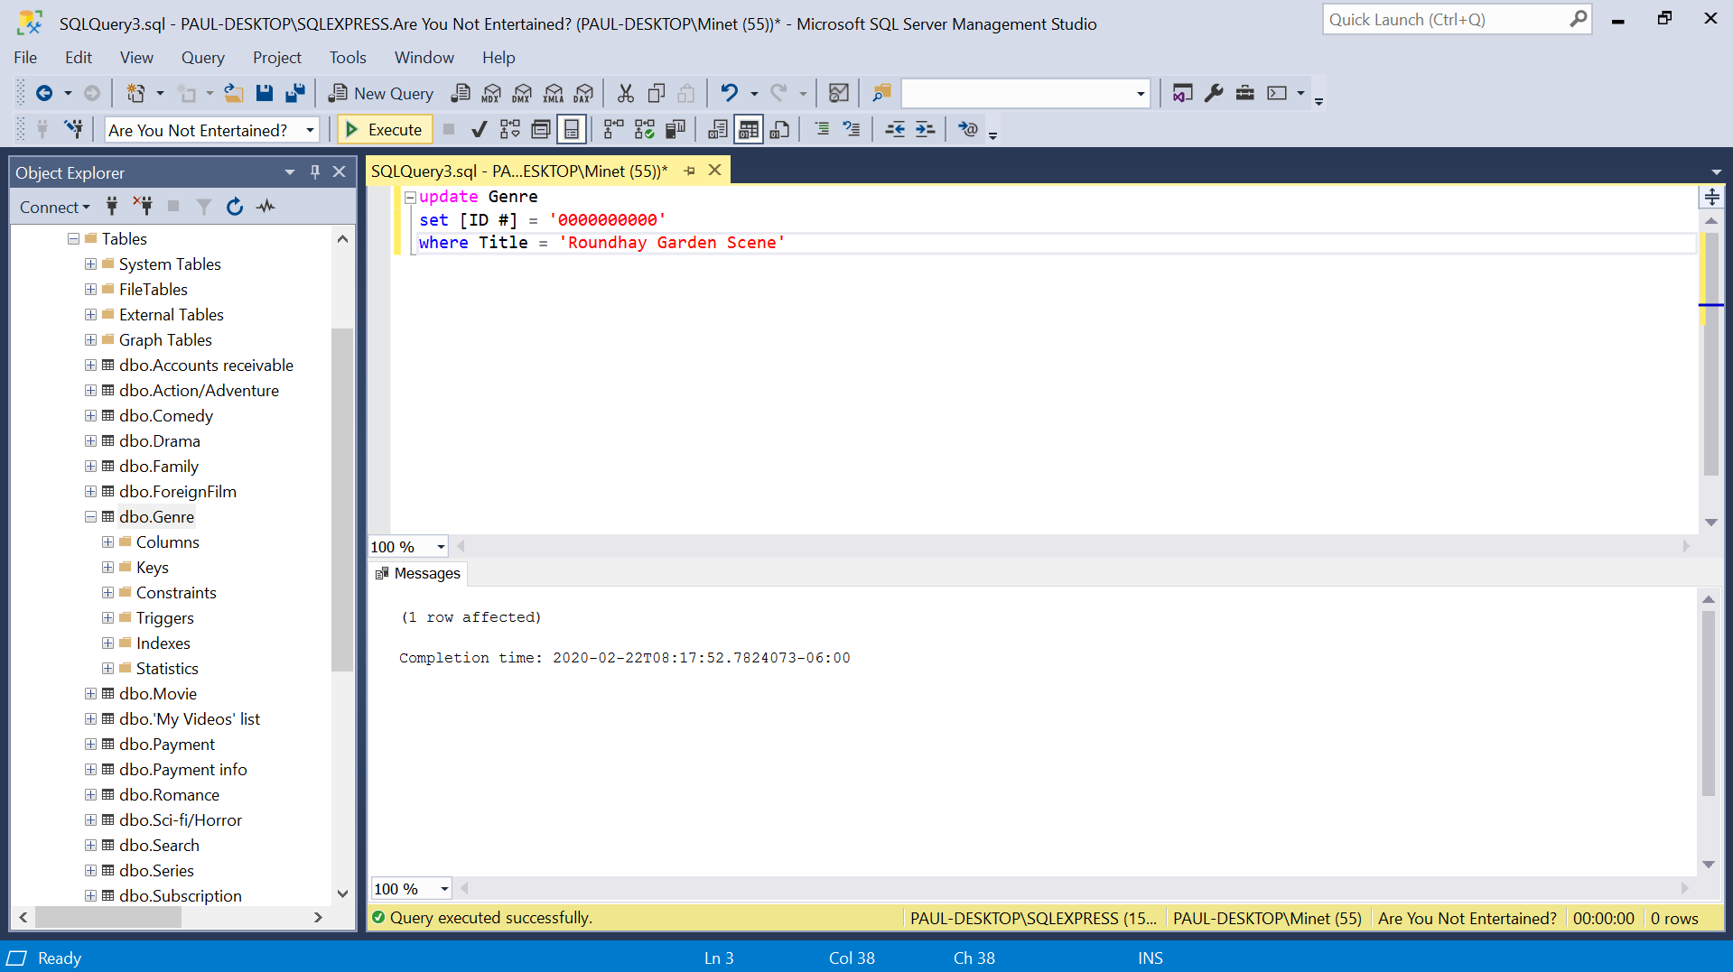

Update 1 row result

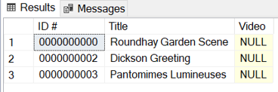

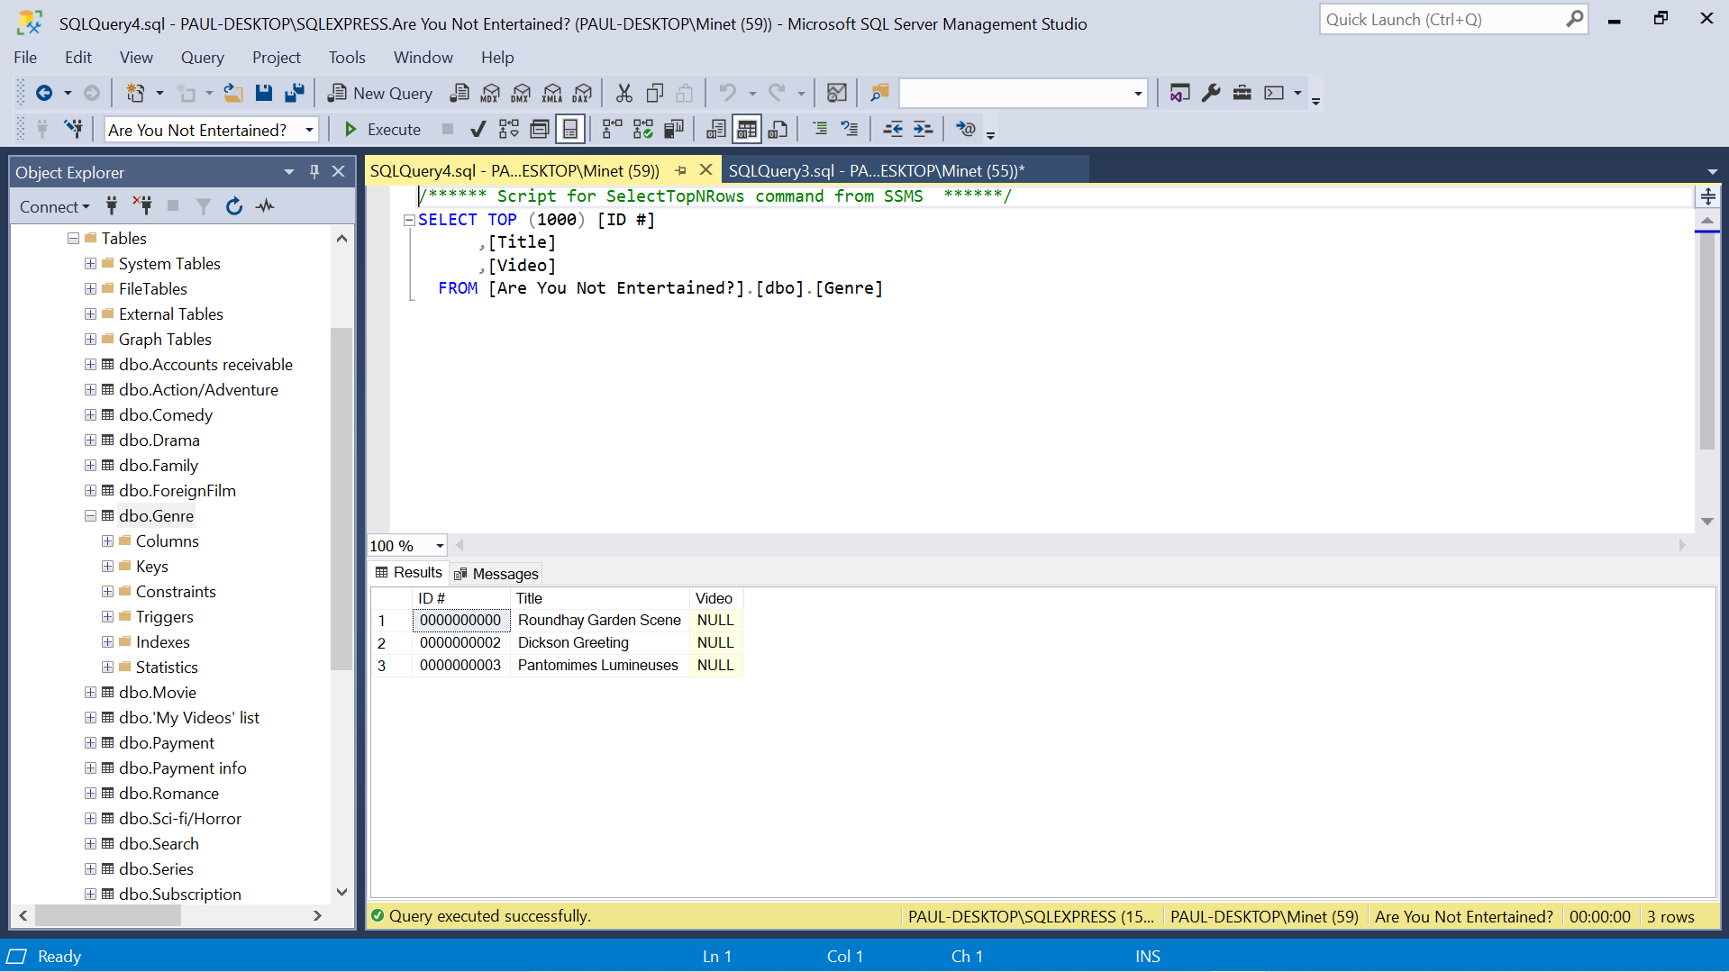

1. Table – Sci-fi/Horror

Insert 3 rows

Insert into [Sci-fi/Horror] ([ID #], Title)

Values (‘0002000000’, ‘Alien’), (‘0003000000’, ‘Aliens’), (‘0001000000’, ‘Blade Runner’)

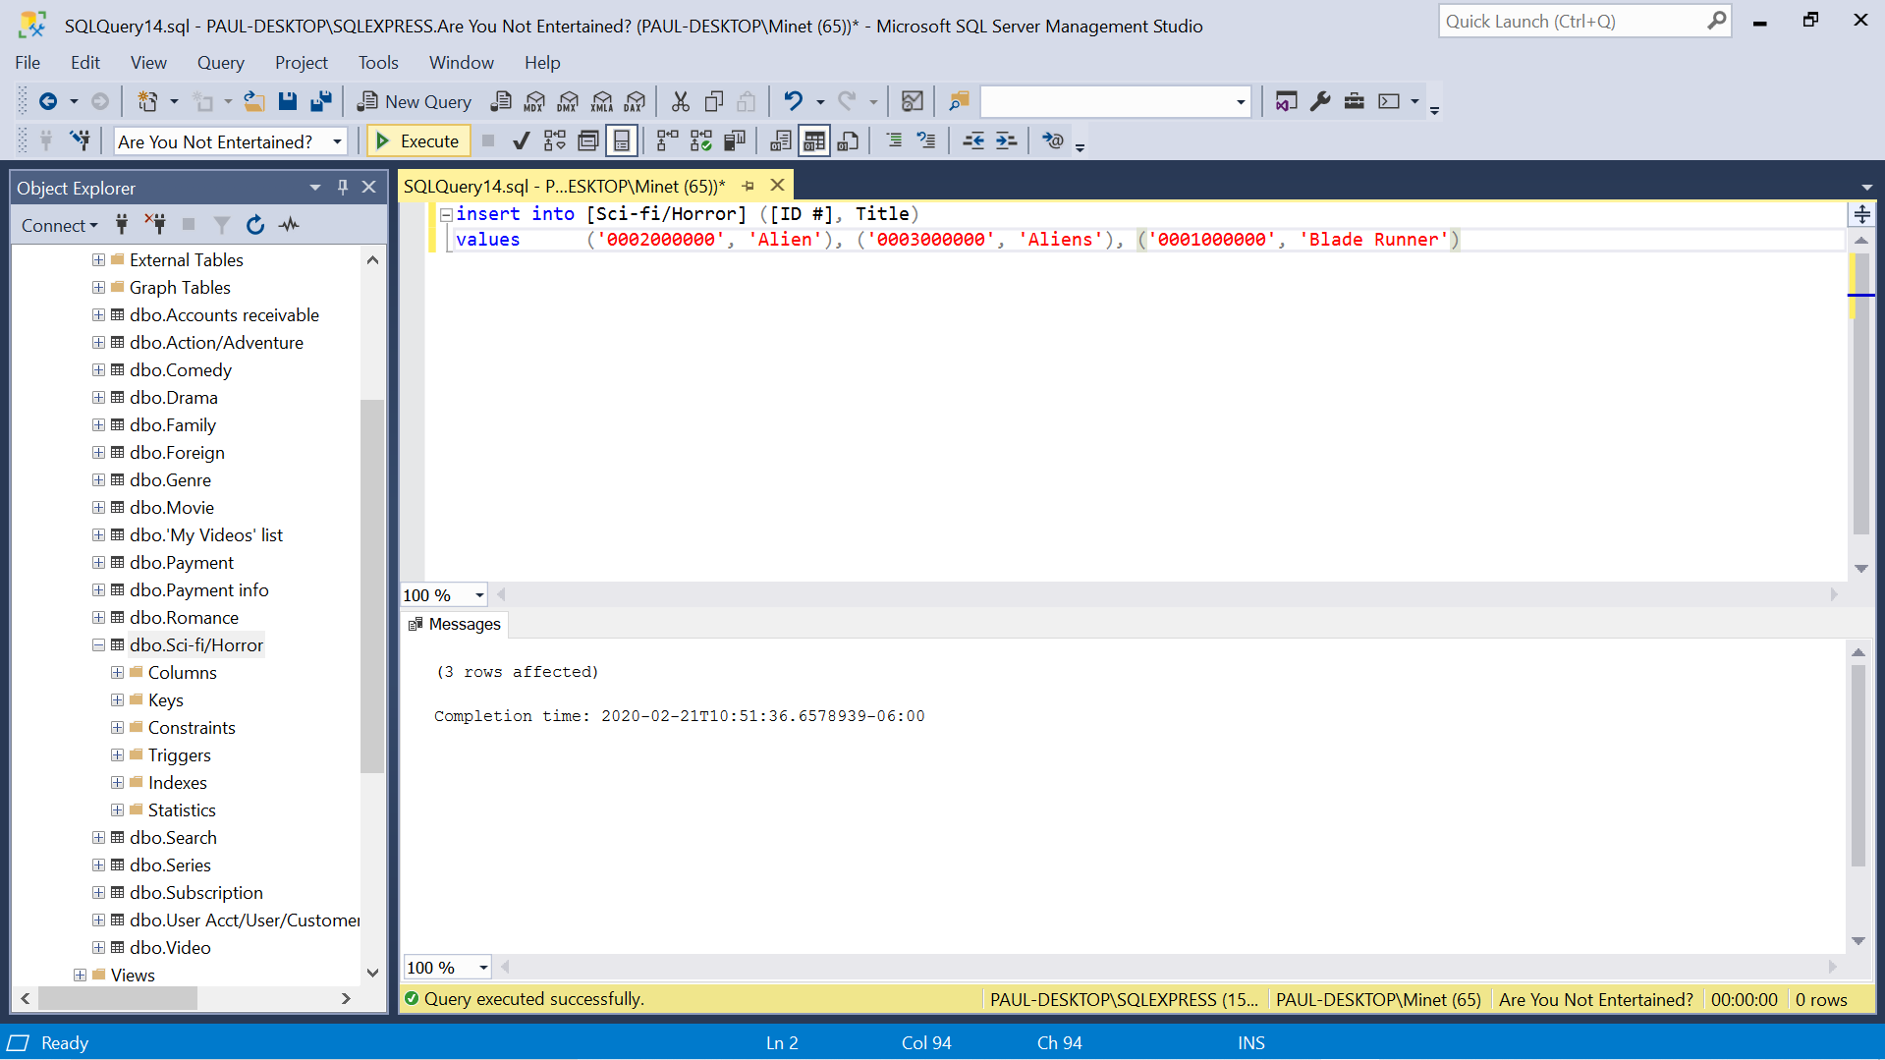

Insert 3 rows result

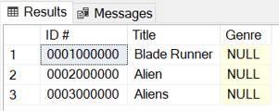

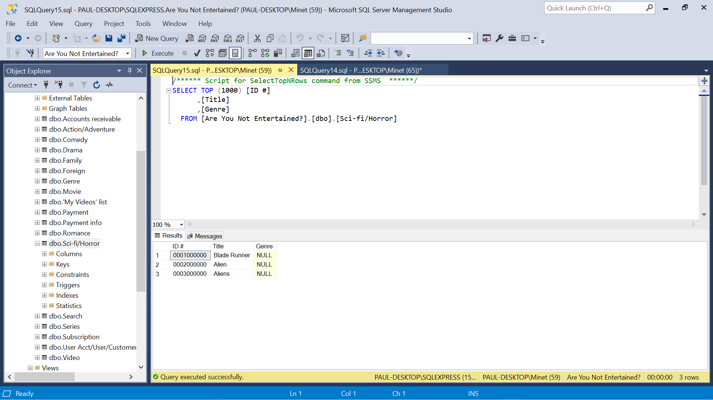

Update 1 row

Update [Sci-fi/Horror]

Set [ID #] = ‘0002200000’

Where Title = ‘Aliens’

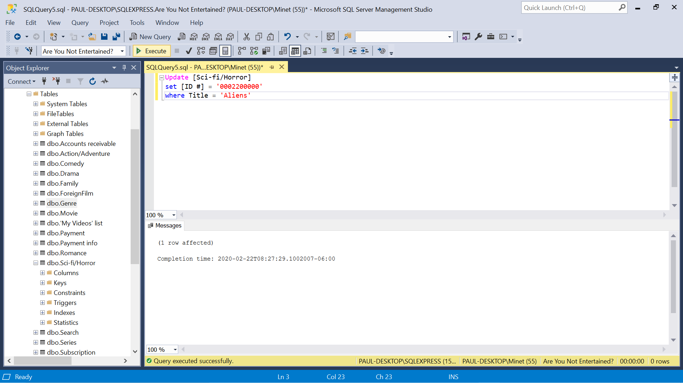

Update 1 row result

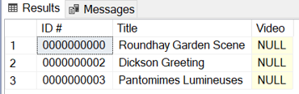

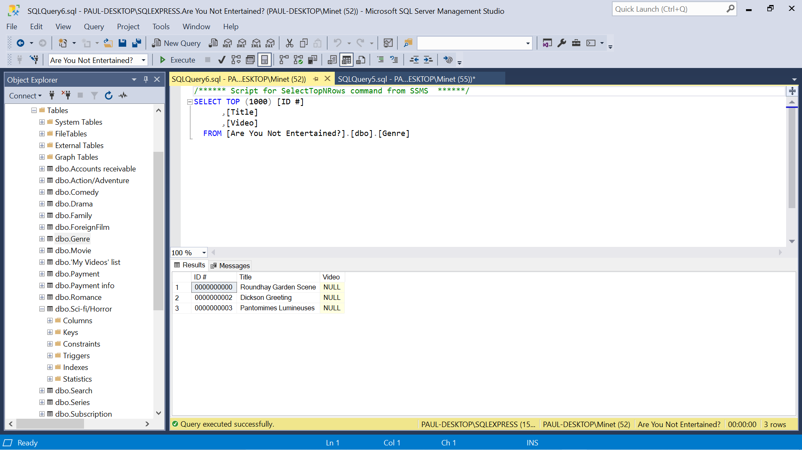

1. Table – Drama

Insert 3 rows

Insert into Drama ([ID #], Title)

Values (‘0000100000’, ‘Sophies Choice’), (‘0000200000’, ‘Citizen Kane’), (‘0000300000’, ‘Casablanca’)

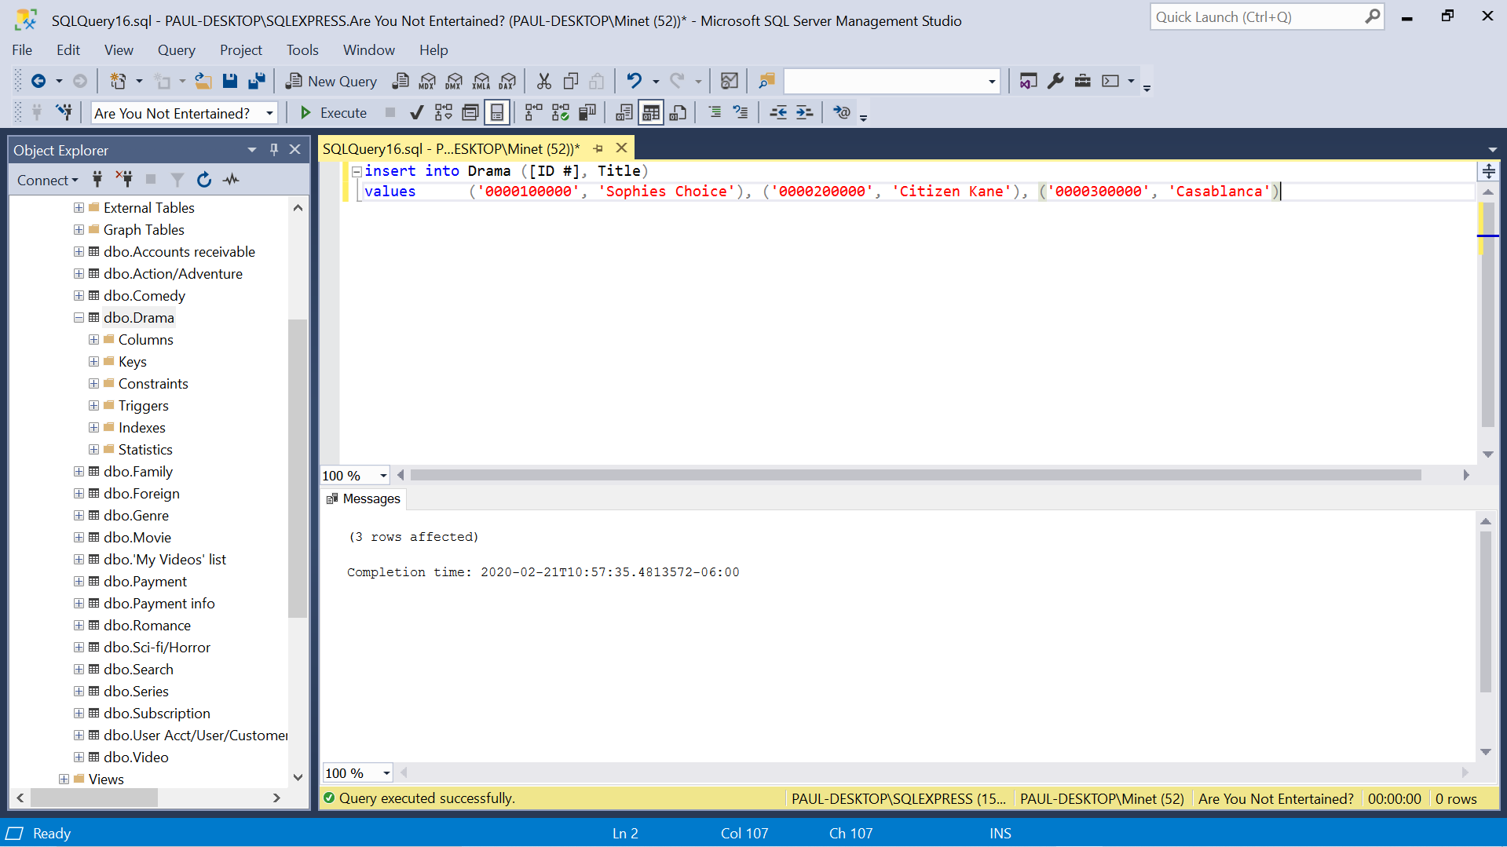

Insert 3 rows result

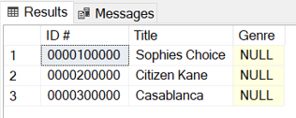

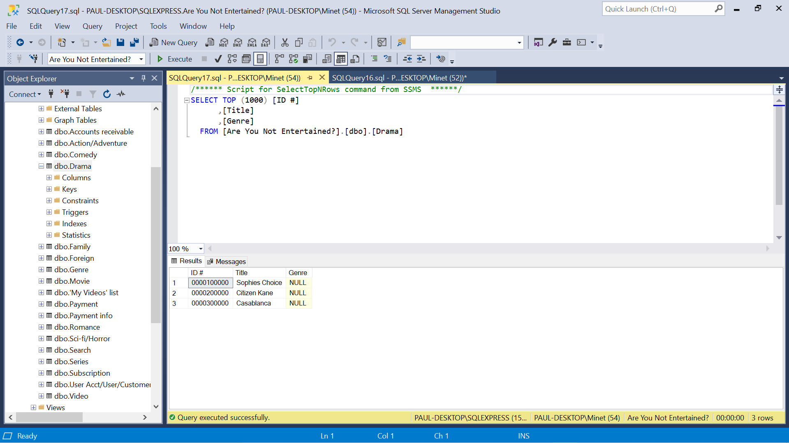

Update 1 row

Update Drama

Set [ID #] = ‘0000110000’

Where Title = ‘Sophies Choice’

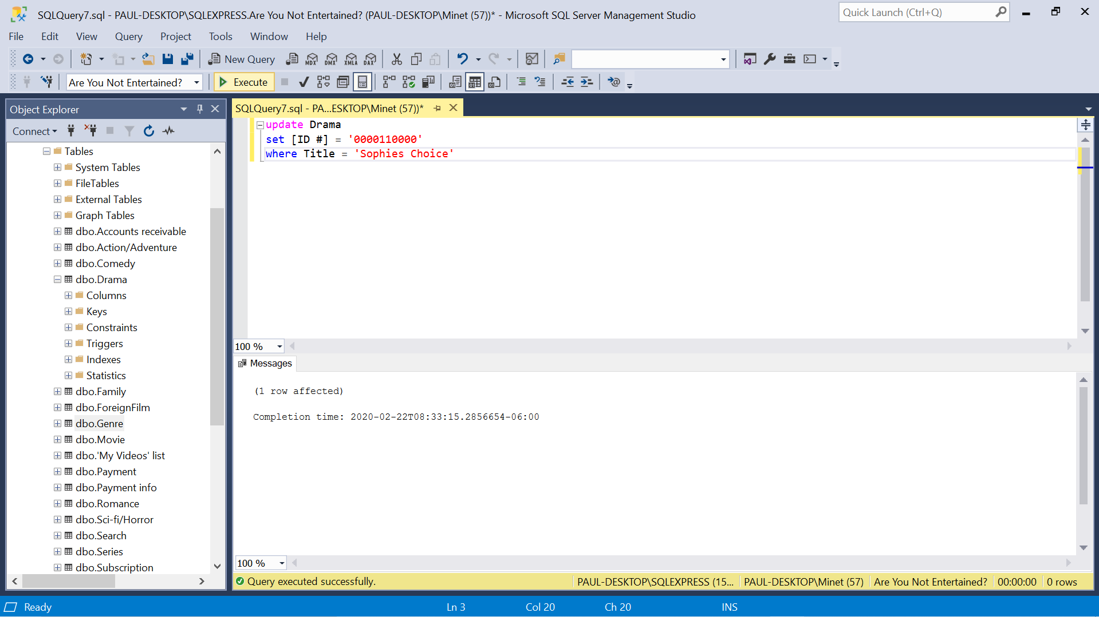

Update 1 row result

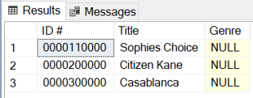

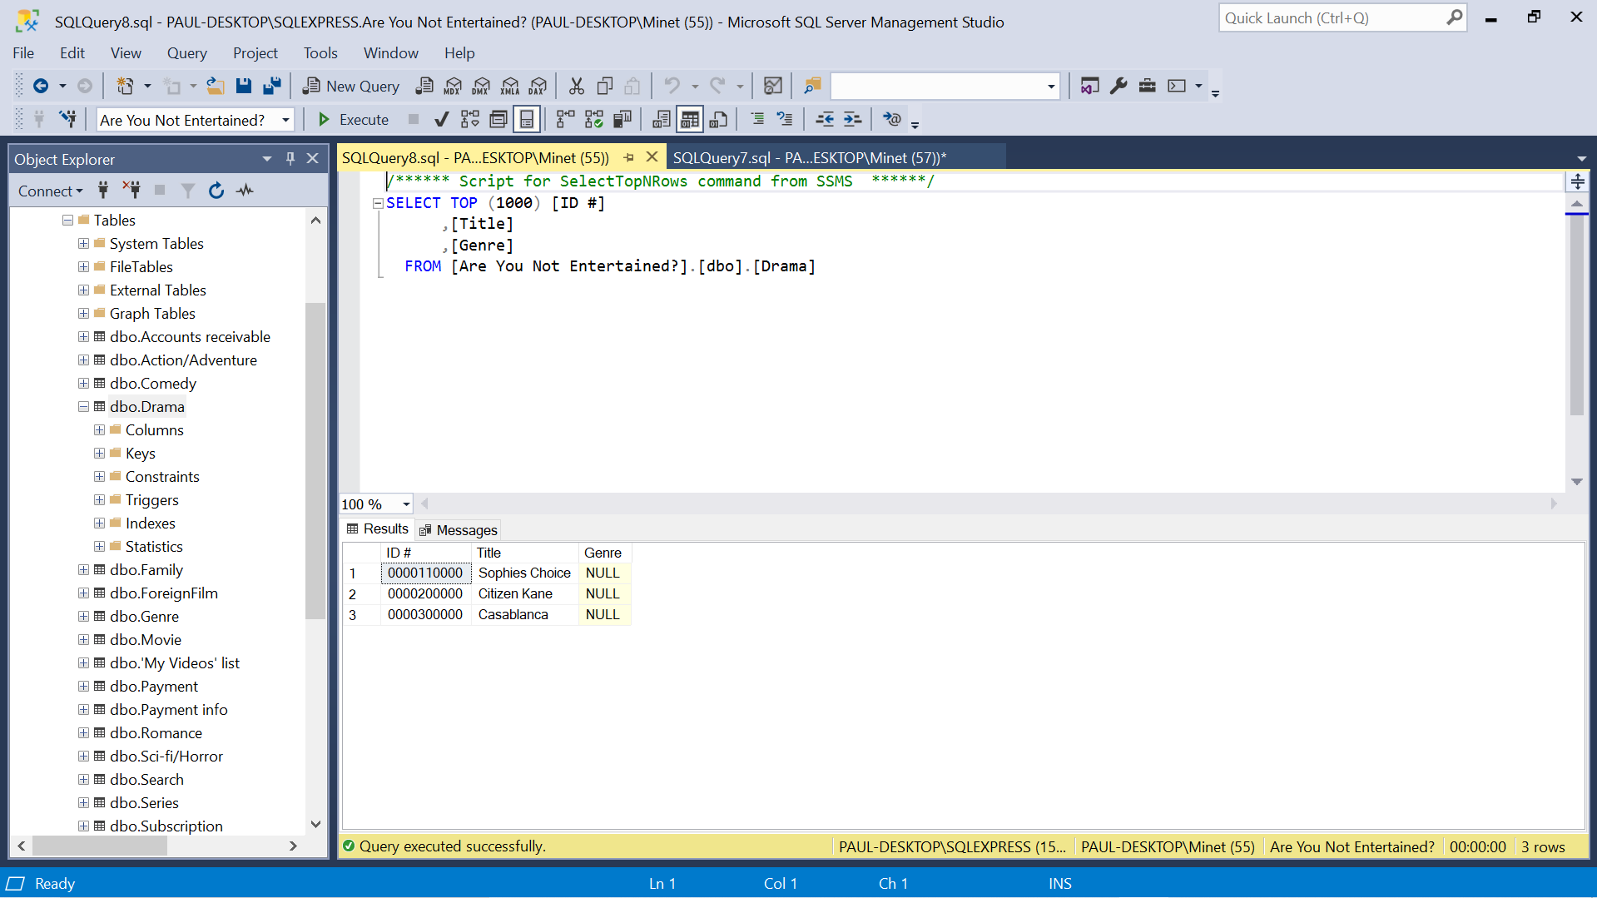

1. Table – Comedy

Insert 3 rows

Insert into Comedy ([ID #], Title)

Values (‘0010000000’, ‘Groundhog Day’), (‘0020000000’, ‘The Court Jester’), (‘0030000000’, ‘Modern Times’)

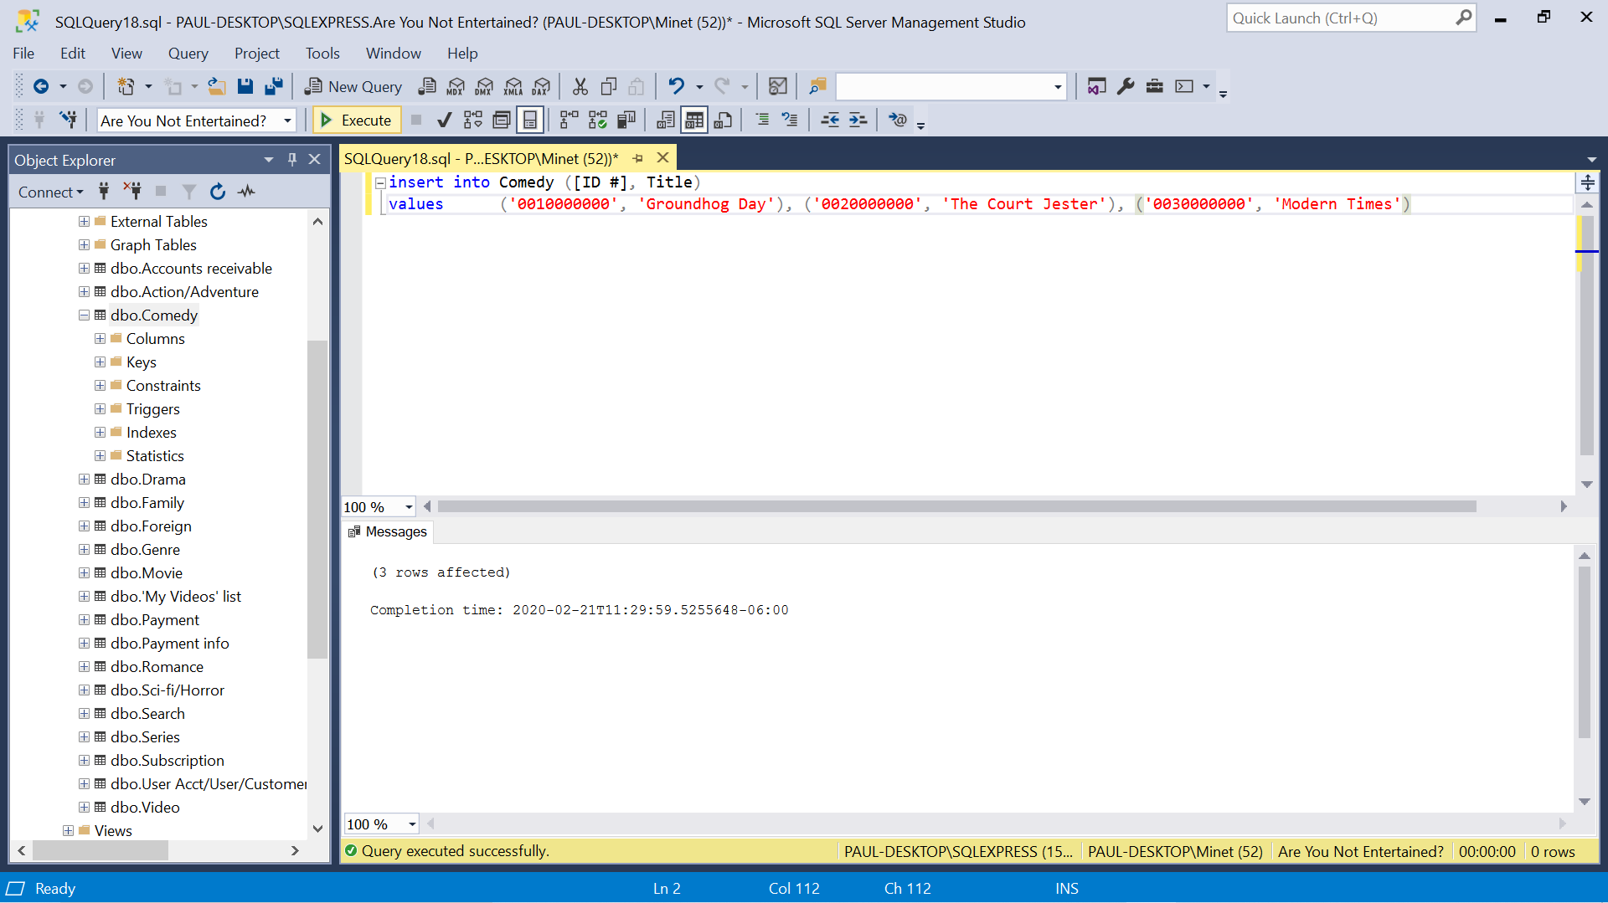

Insert 3 rows result

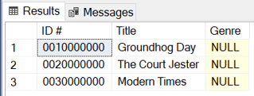

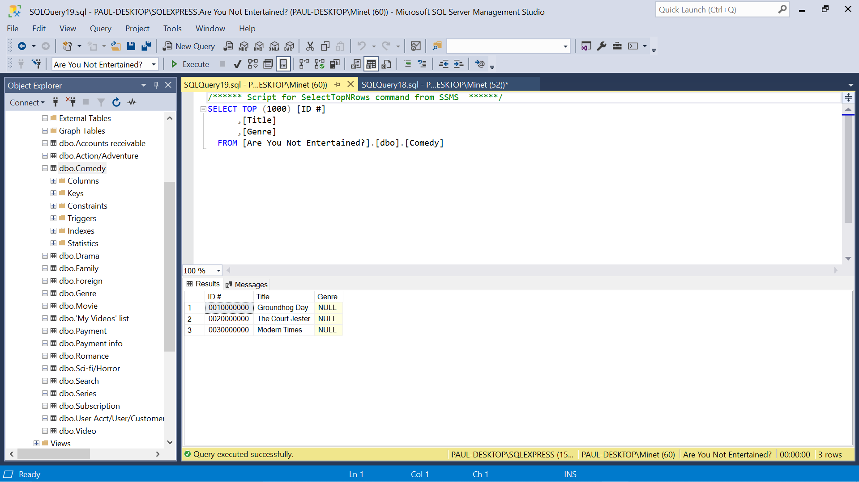

Update 1 row

Update Comedy

Set [ID #] = ‘0011000000’

Where Title = ‘Groundhog Day’

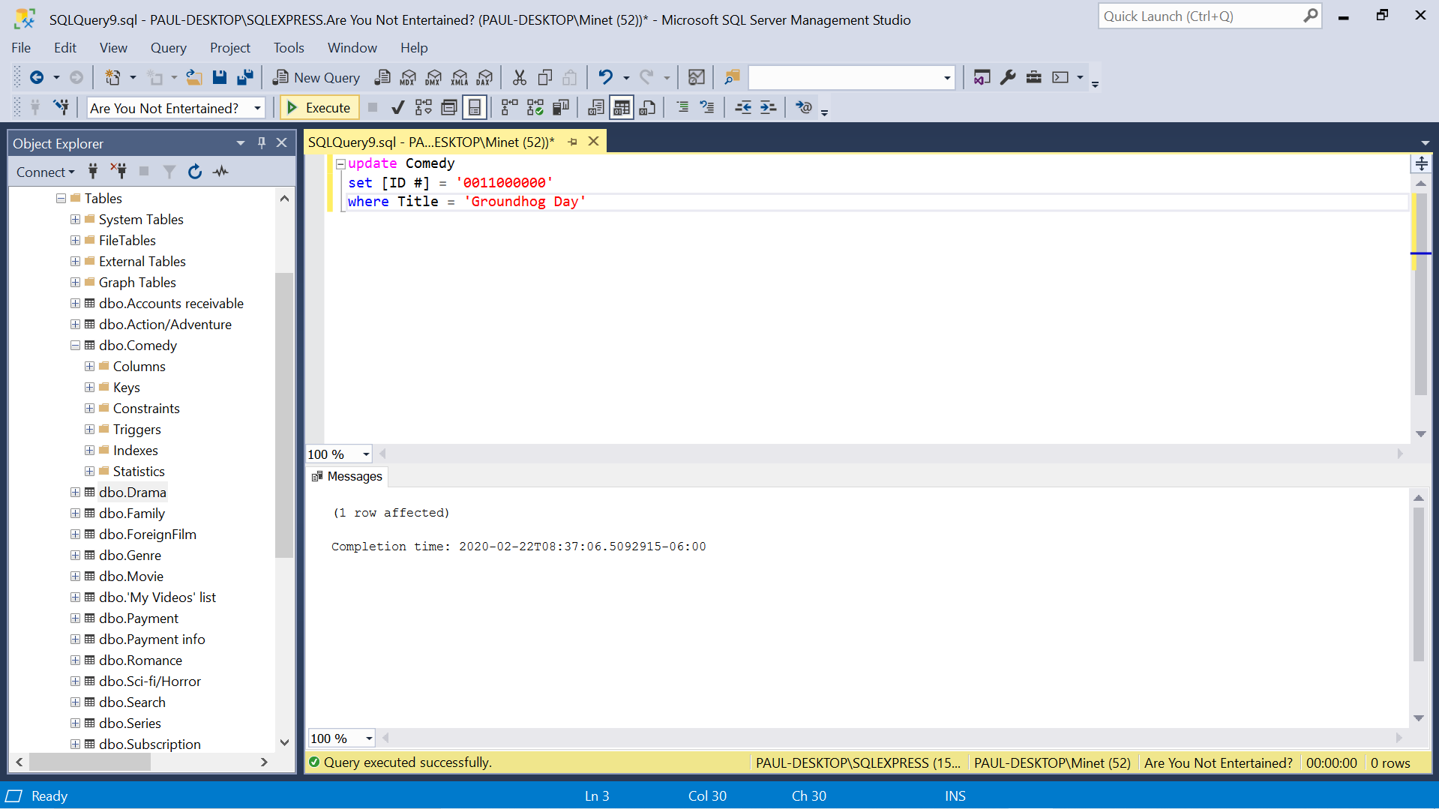

Update 1 row result

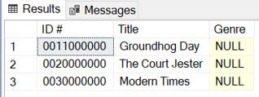

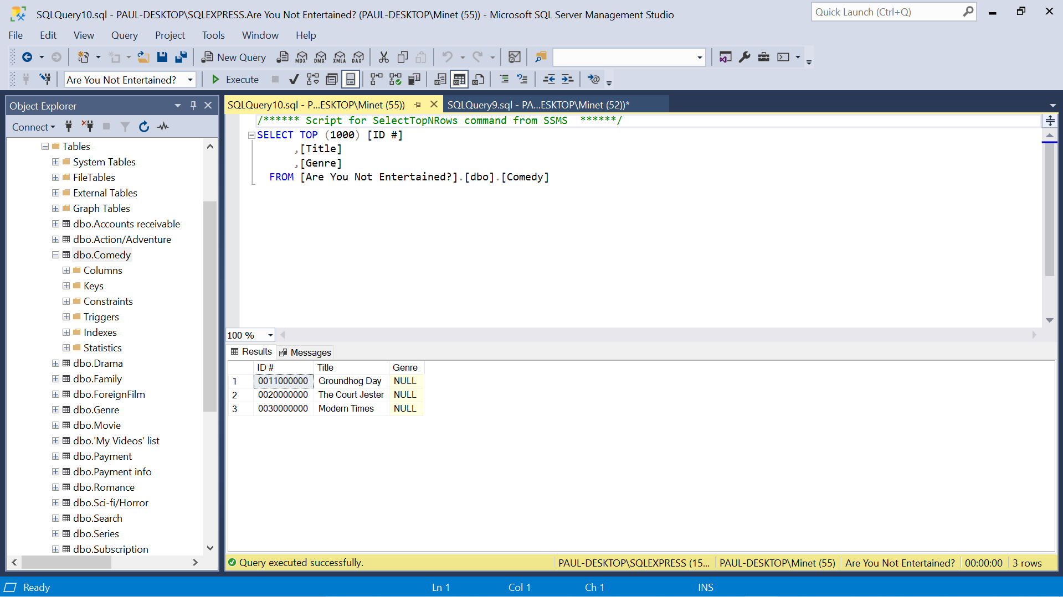

1. Table – Family

Insert 3 rows

Insert into Family ([ID #], Title)

Values (‘0100000000’, ‘Moanna’), (‘0200000000’, ‘Big’), (‘0300000000’, ‘James and the Giant Peach’)

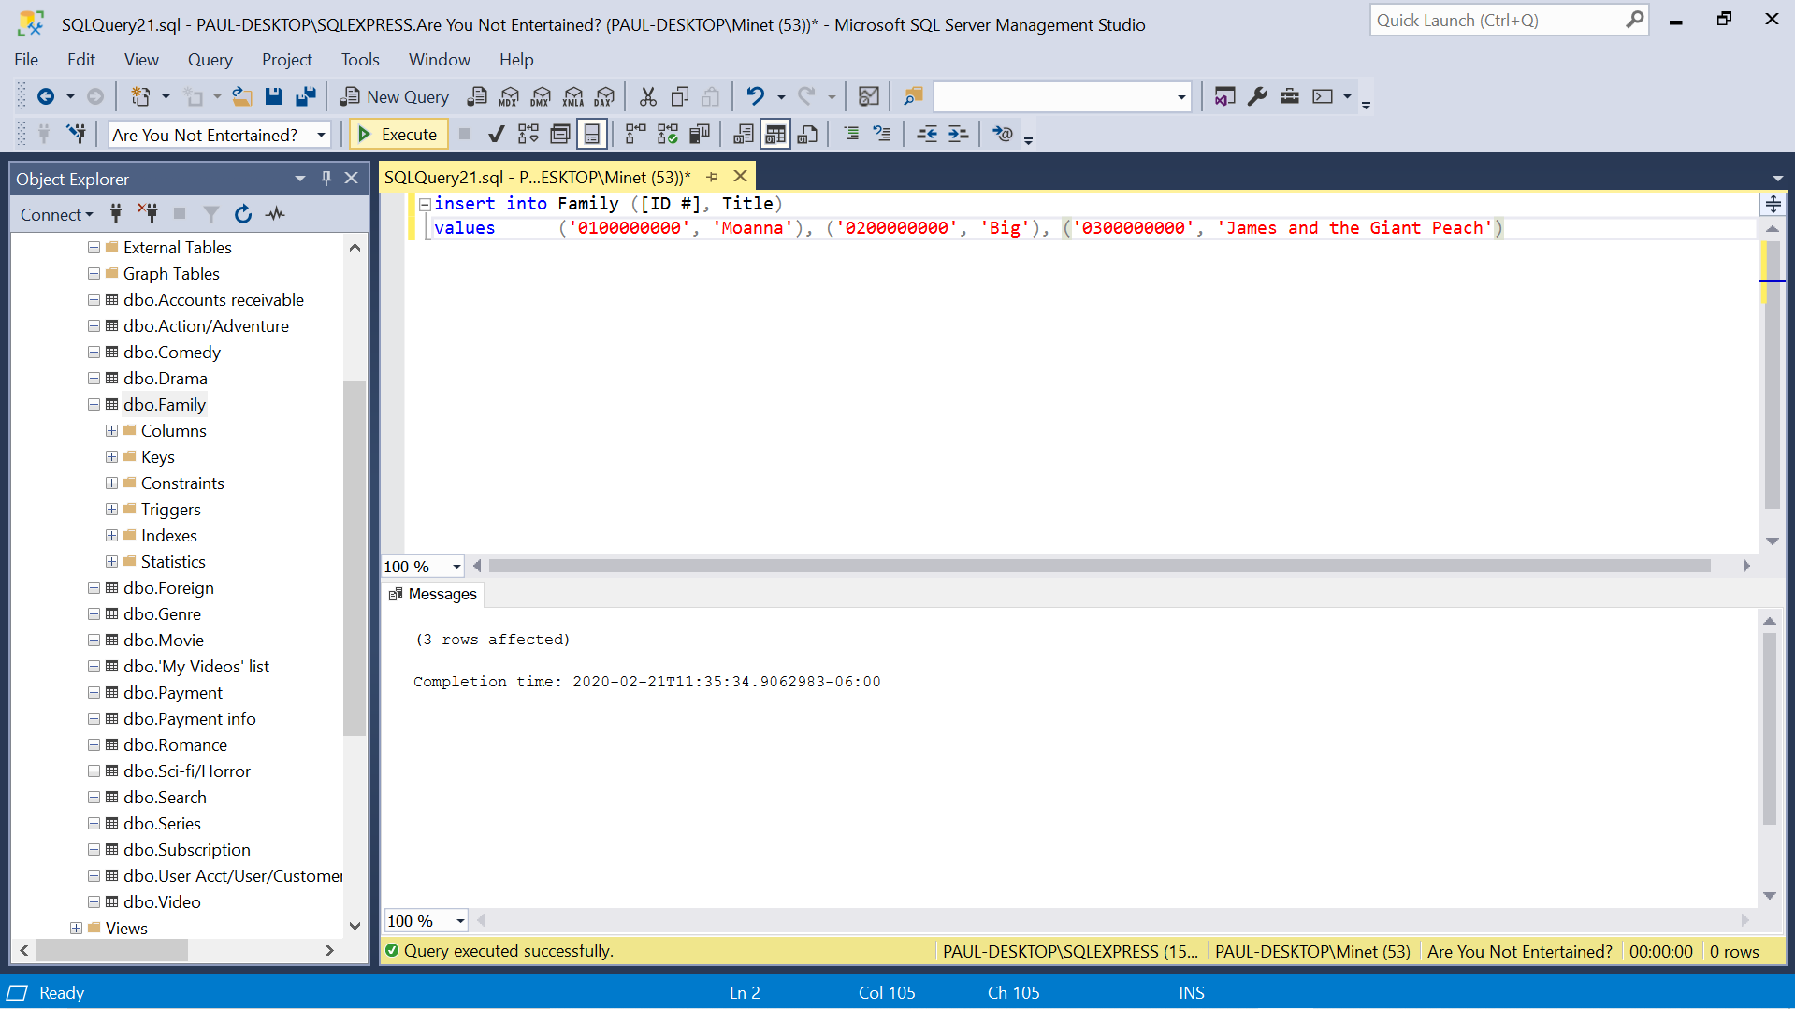

Insert 3 rows result

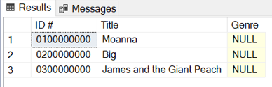

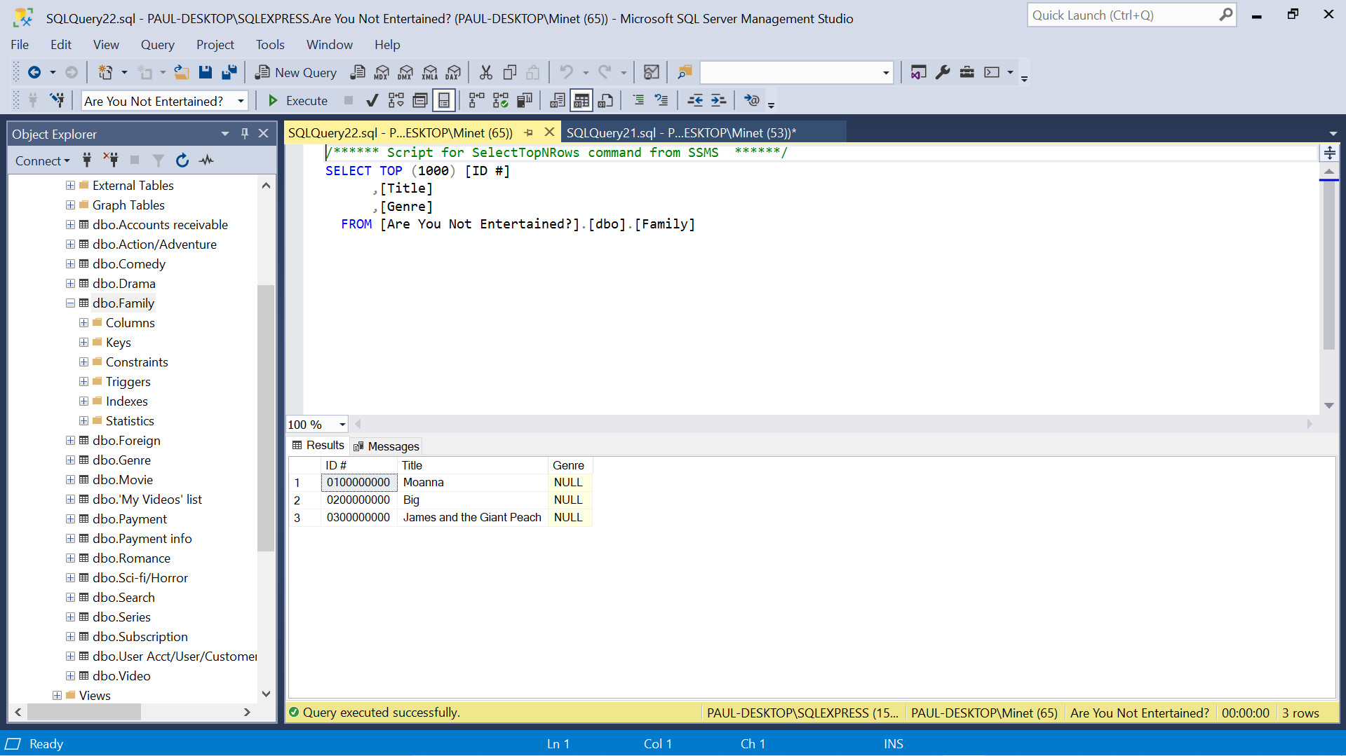

Update 1 row

Update Family

Set [ID #] = ‘0110000000’

Where Title = ‘Moanna’

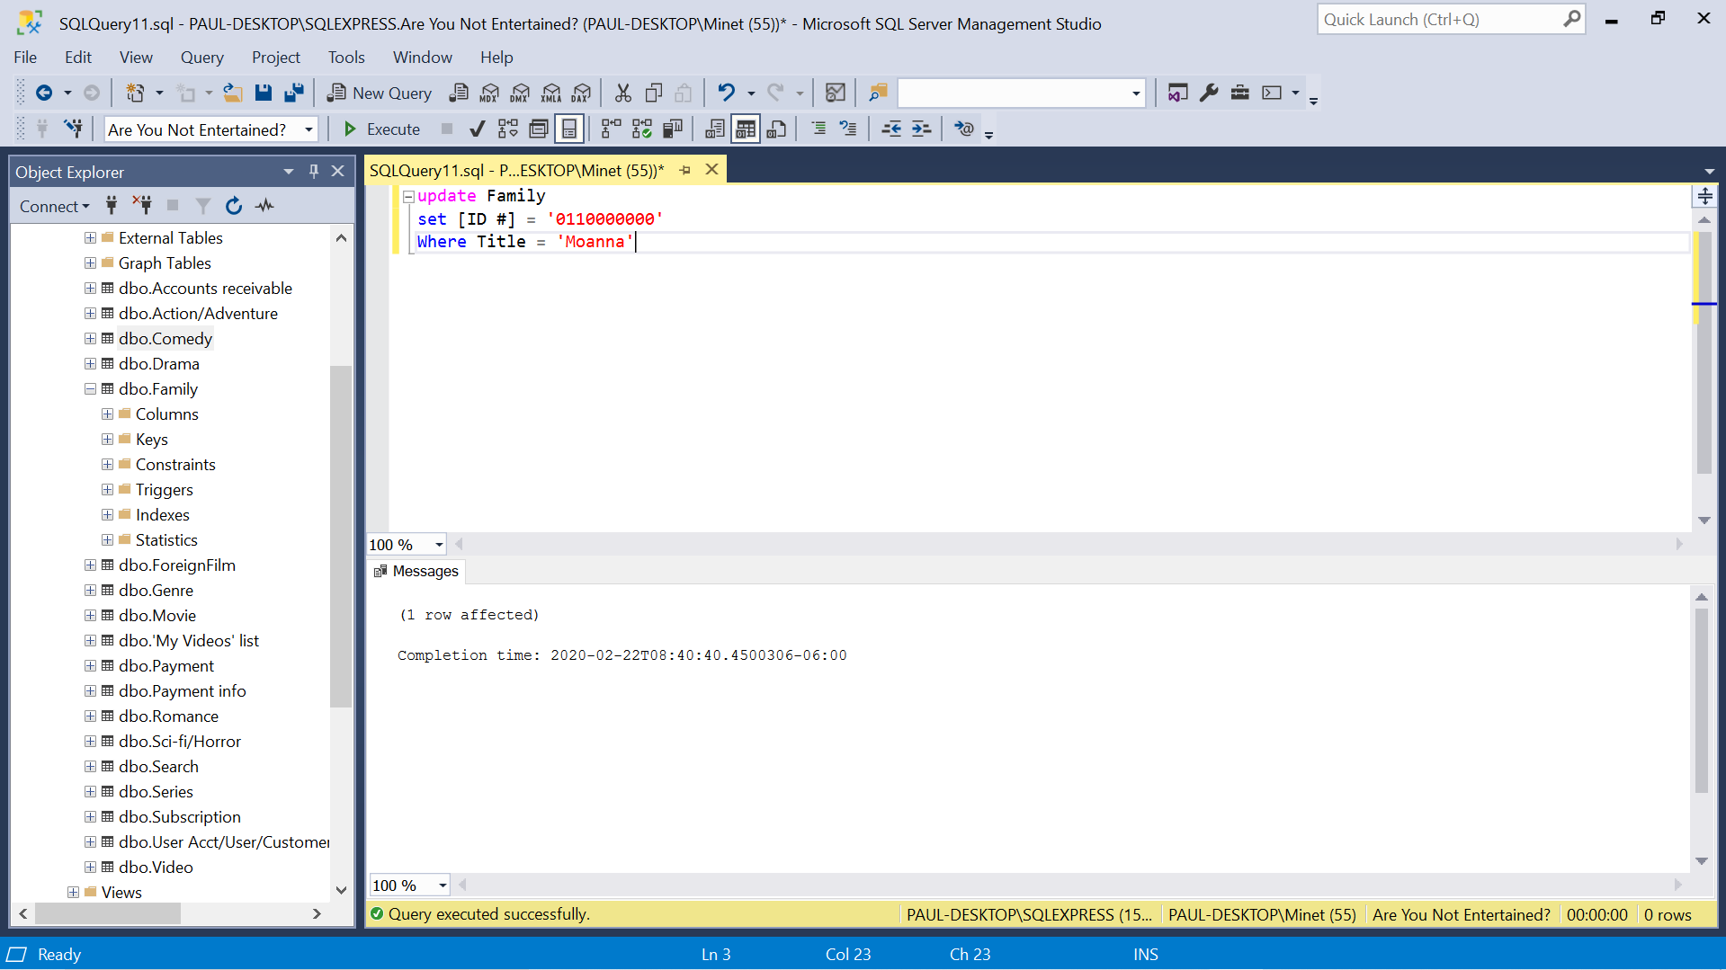

Update 1 row result

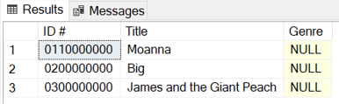

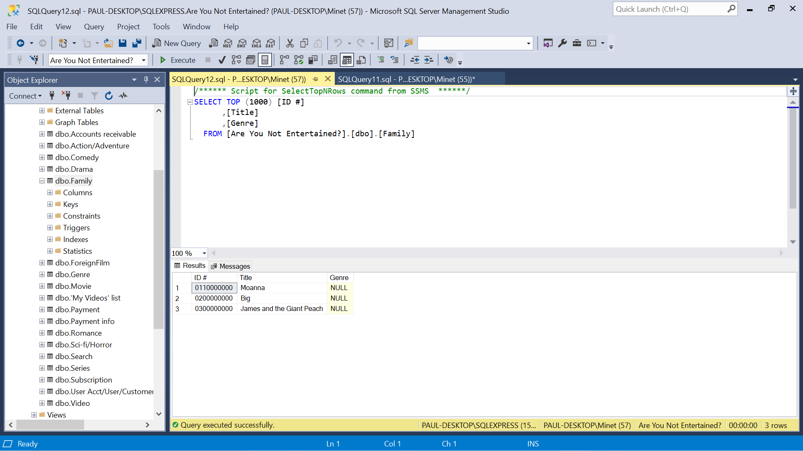

1. Table – Romance

Insert 3 rows

Insert into Romance ([ID #], Title)

Values (‘0000000010’, ‘The Notebook’), (‘0000000020’, ‘When Harry Met Sally’), (‘0000000030’, ‘Pretty Woman’)

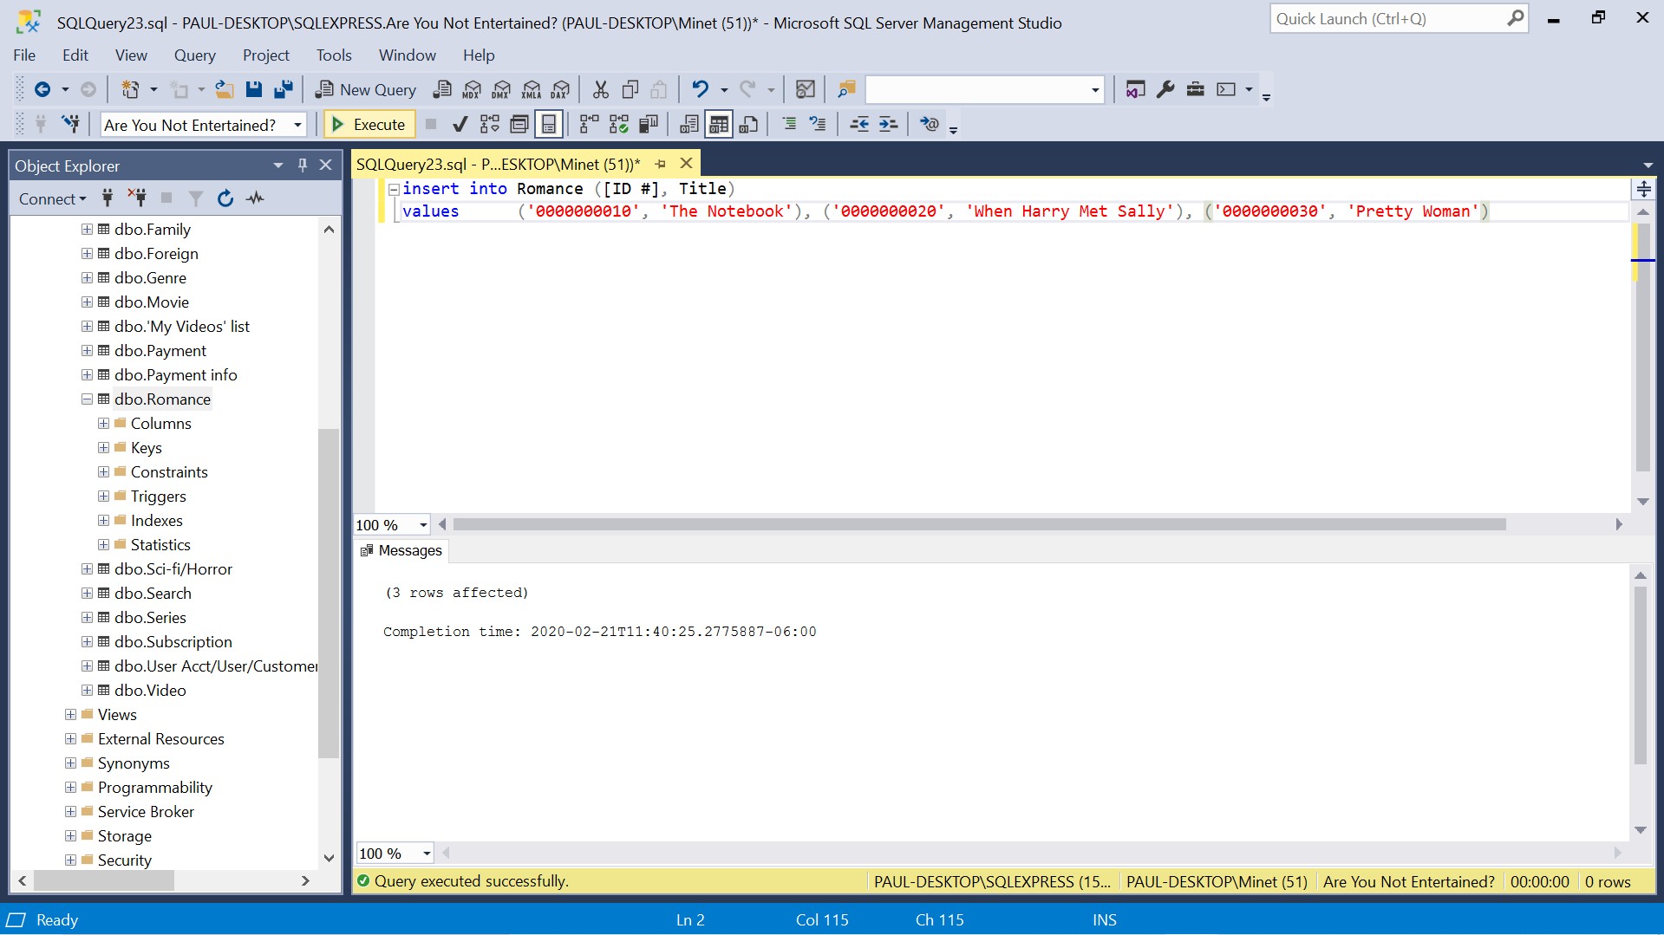

Insert 3 rows result

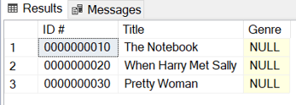

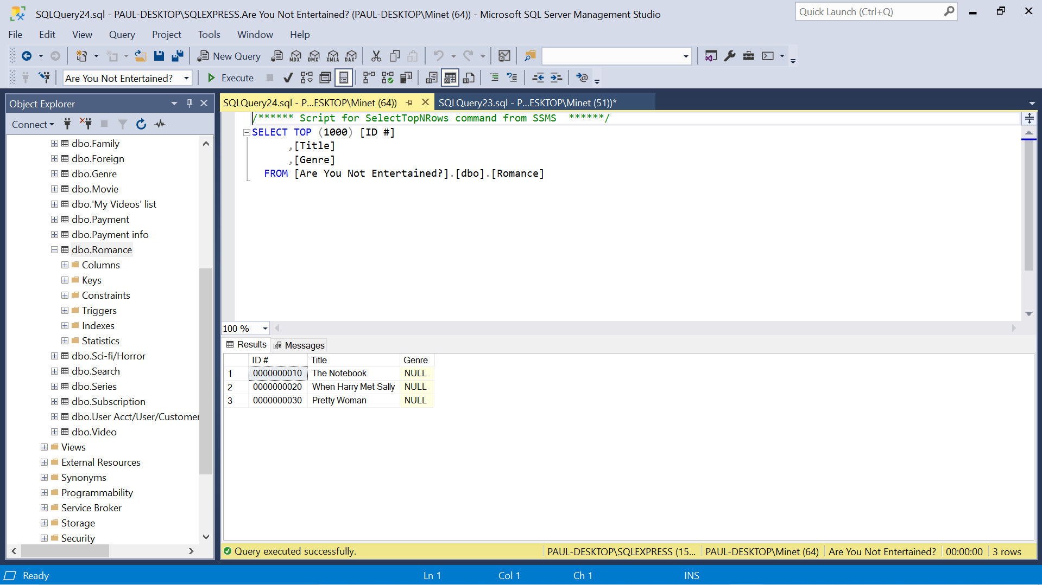

Update 1 row

update Romance

set [ID #] = '0000000011'

where Title = 'The Notebook'

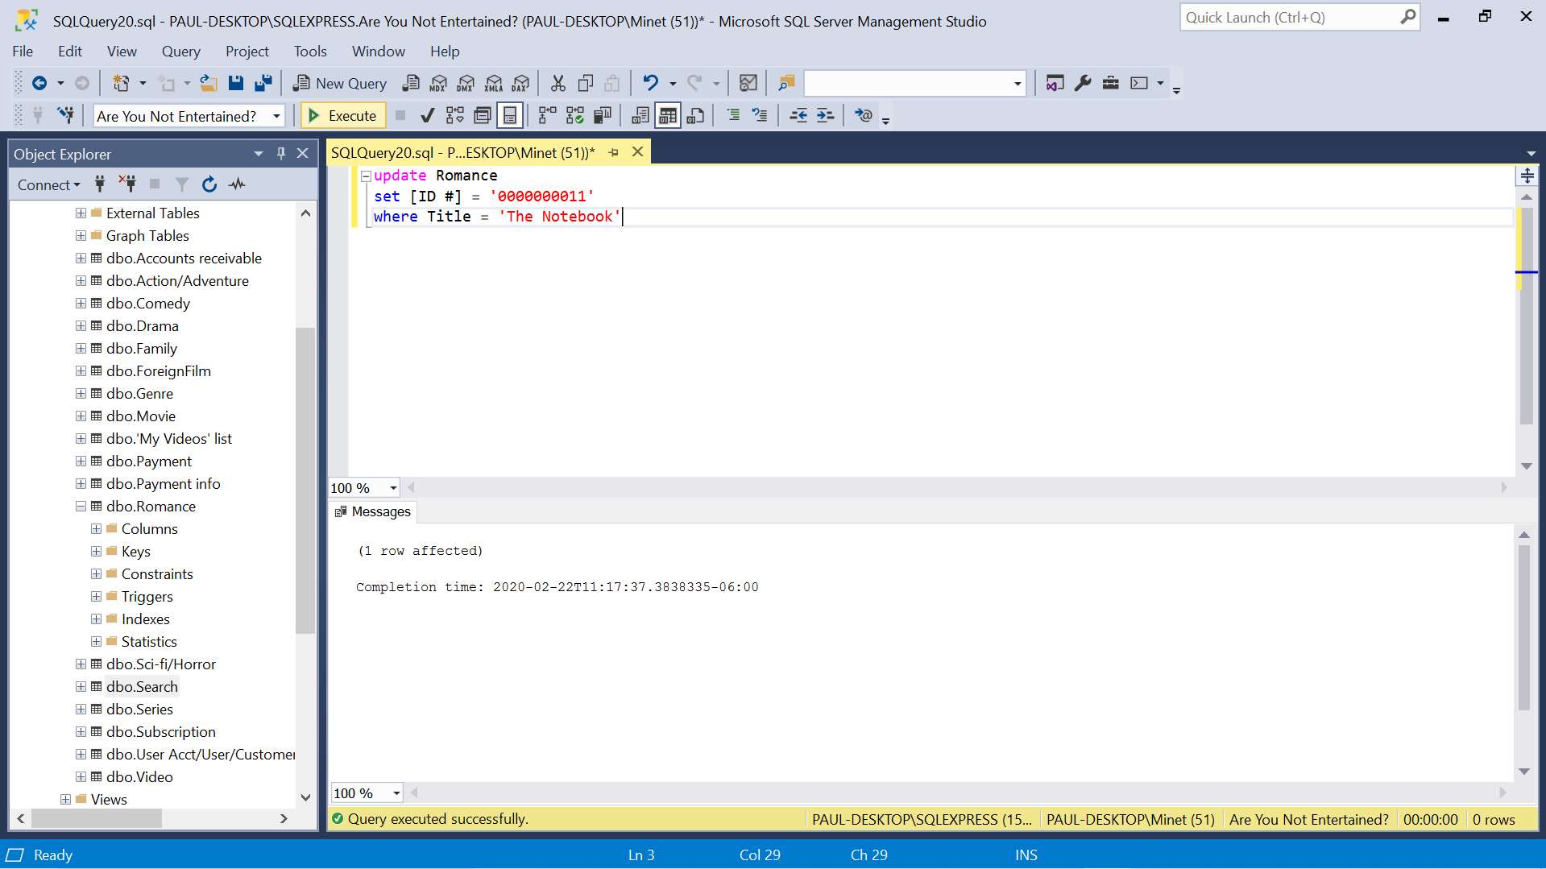

Update 1 row result

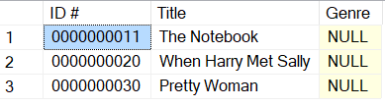

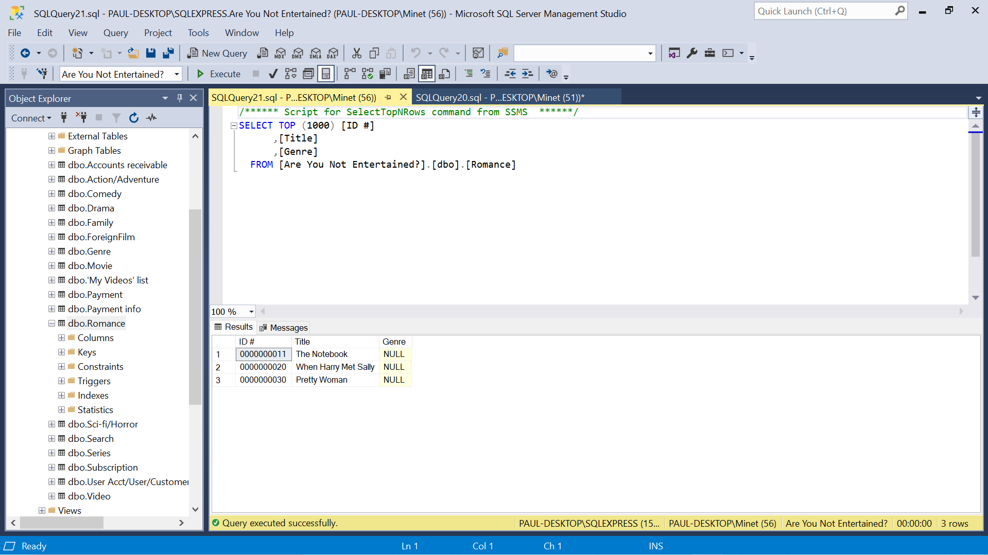

1. Table – Action/Adventure

Insert 3 rows

Insert into [Action/Adventure] ([ID #], Title)

Values (‘0000000100’, ‘Raiders of the Lost Ark’), (‘0000000200’, ‘Avengers’), (‘0000000300’, ‘Jurassic Park’)

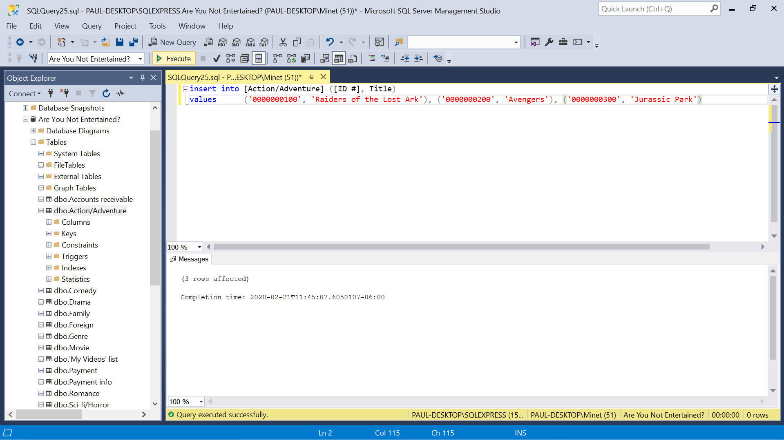

Insert 3 rows result

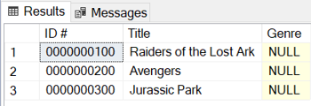

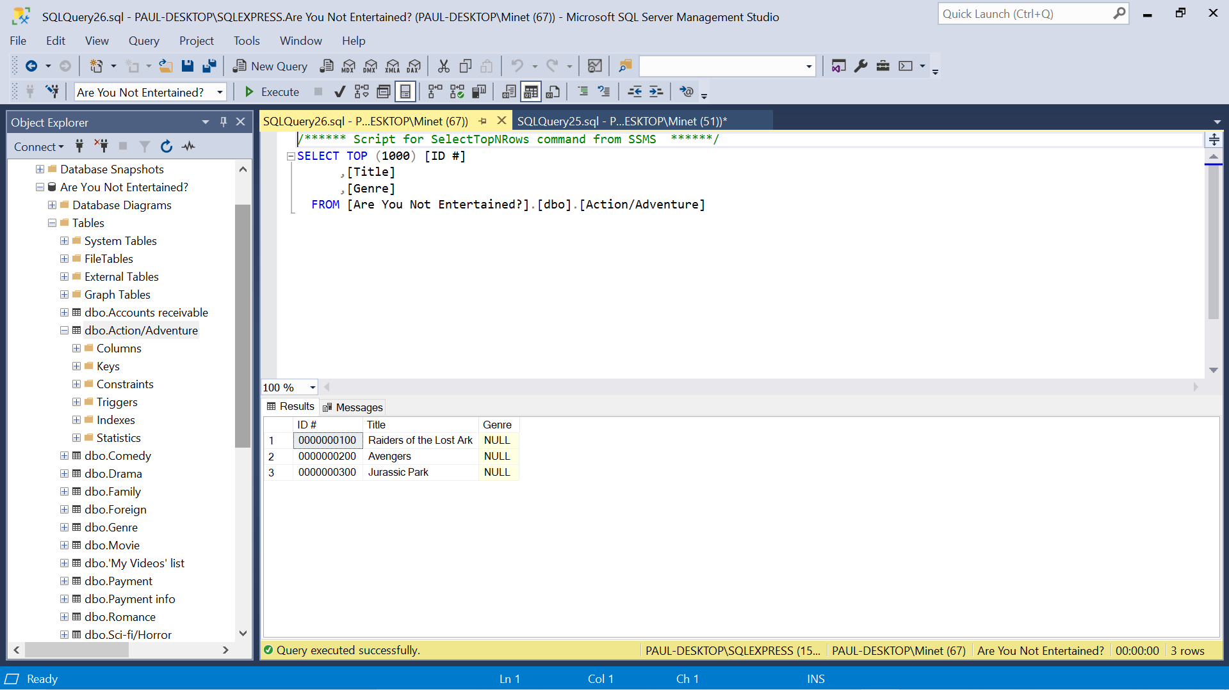

Update 1 row

Update [Action/Adventure]

Set [ID #] = ‘0000000110’

Where Title = ‘Raiders of the Lost Ark’

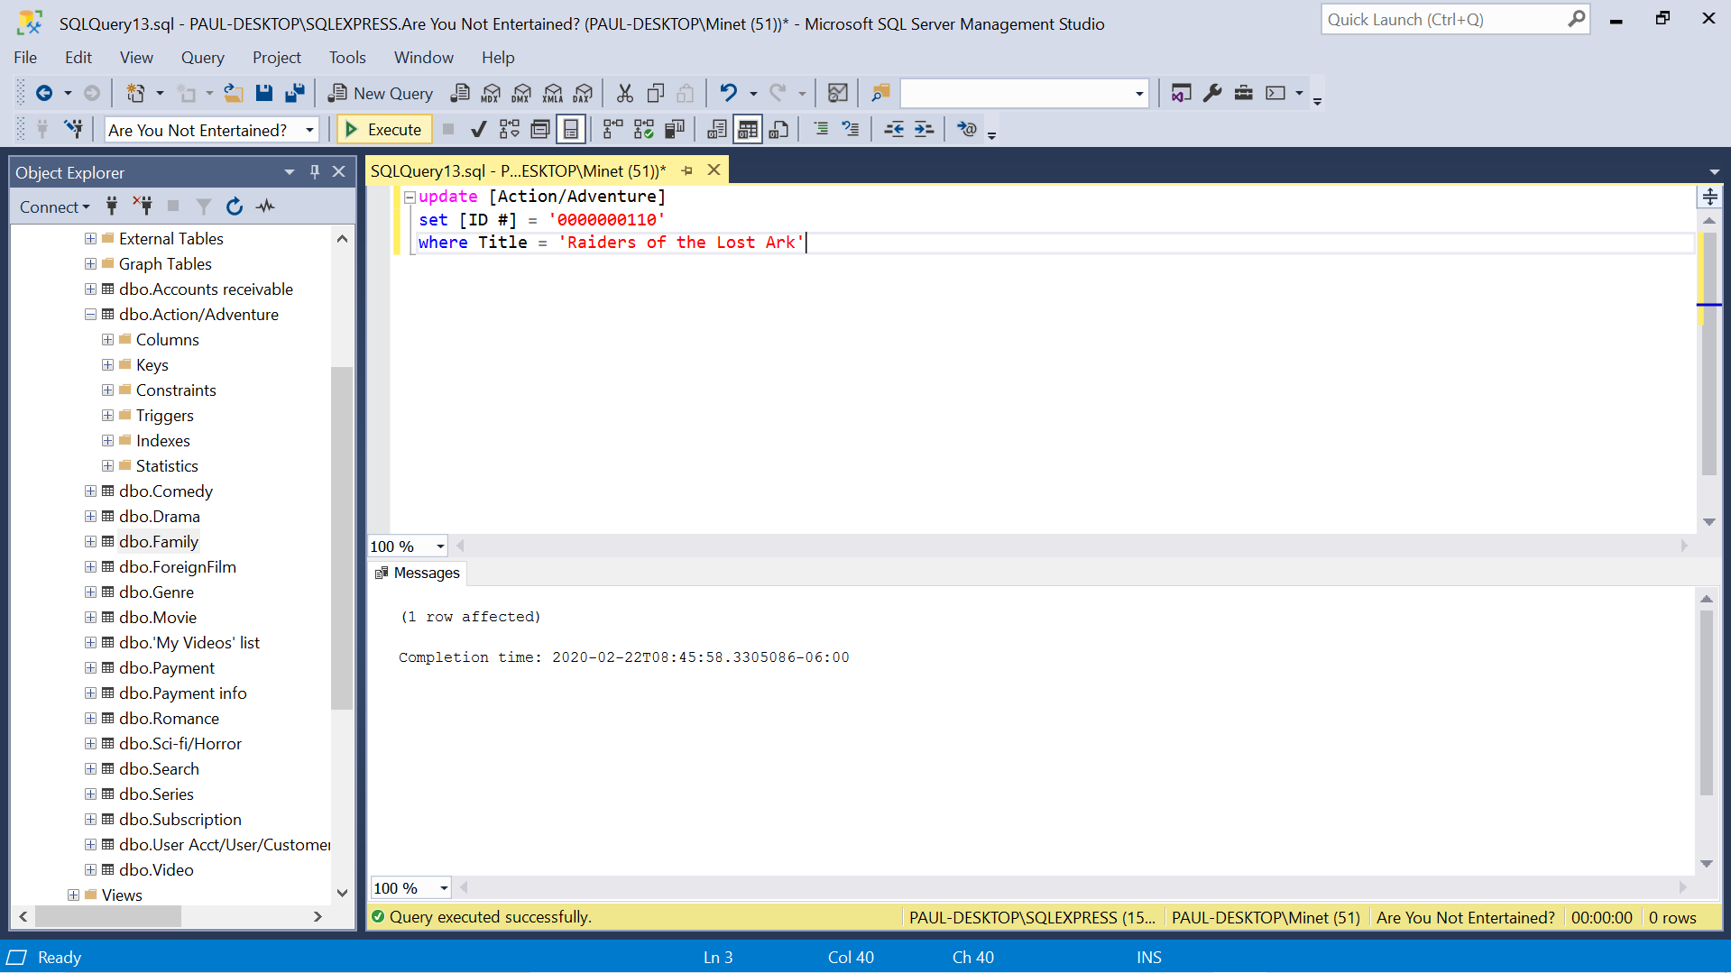

Update 1 row result

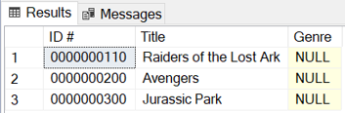

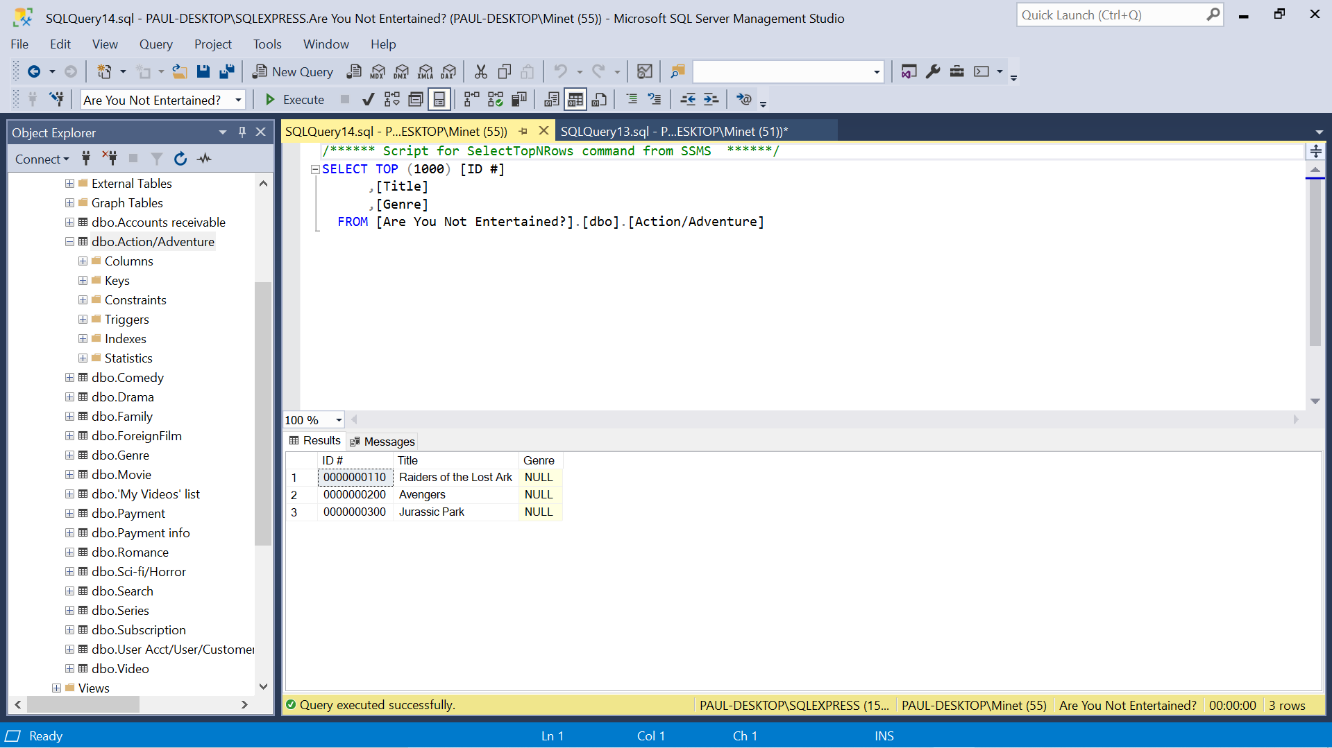

1. Table – ForeignFilm

Insert 3 rows

Insert into ForeignFilm ([ID #], Title)

Values (‘0000001000’, Parasite’), (‘0000002000’, ‘The Bicycle Thief’), (‘0000003000’, ‘Metropolis’)

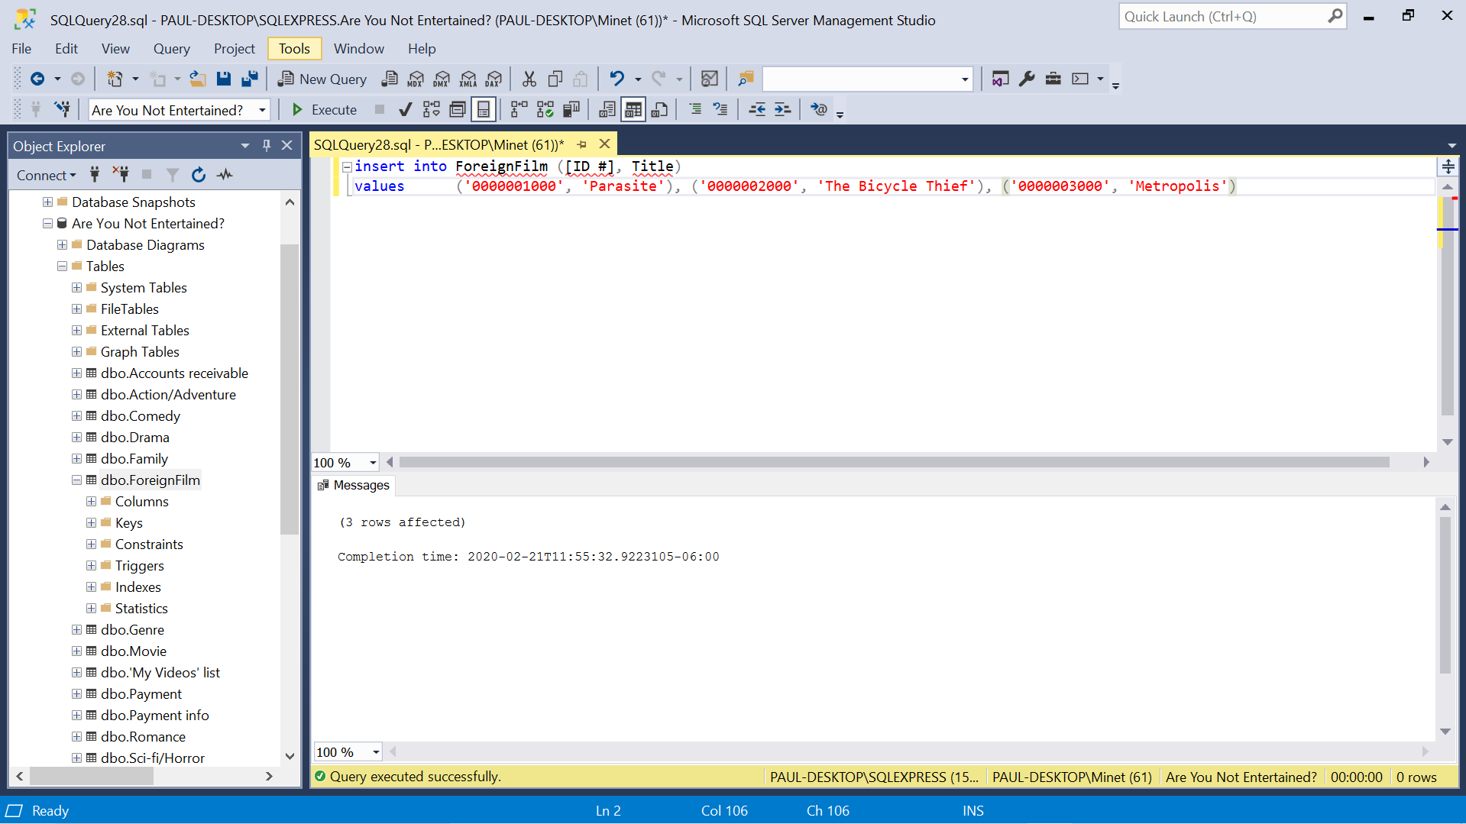

Insert 3 rows result

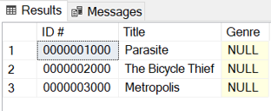

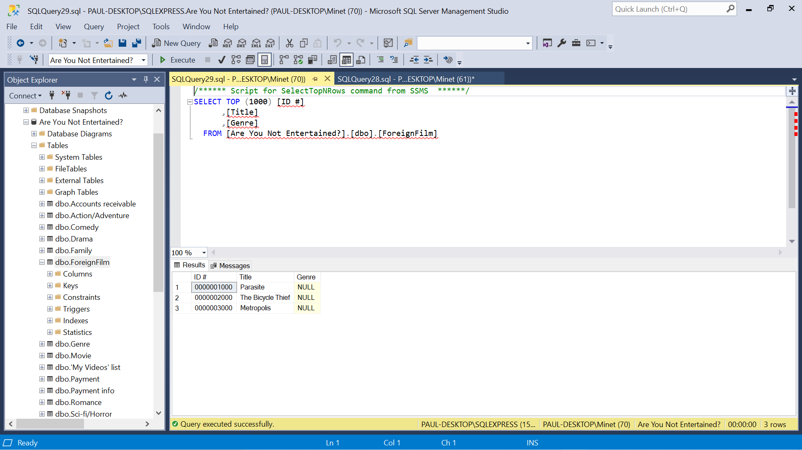

Update 1 row

Update ForeignFilm

Set [ID #] = ‘0000001100’

Where Title = ‘Parasite’

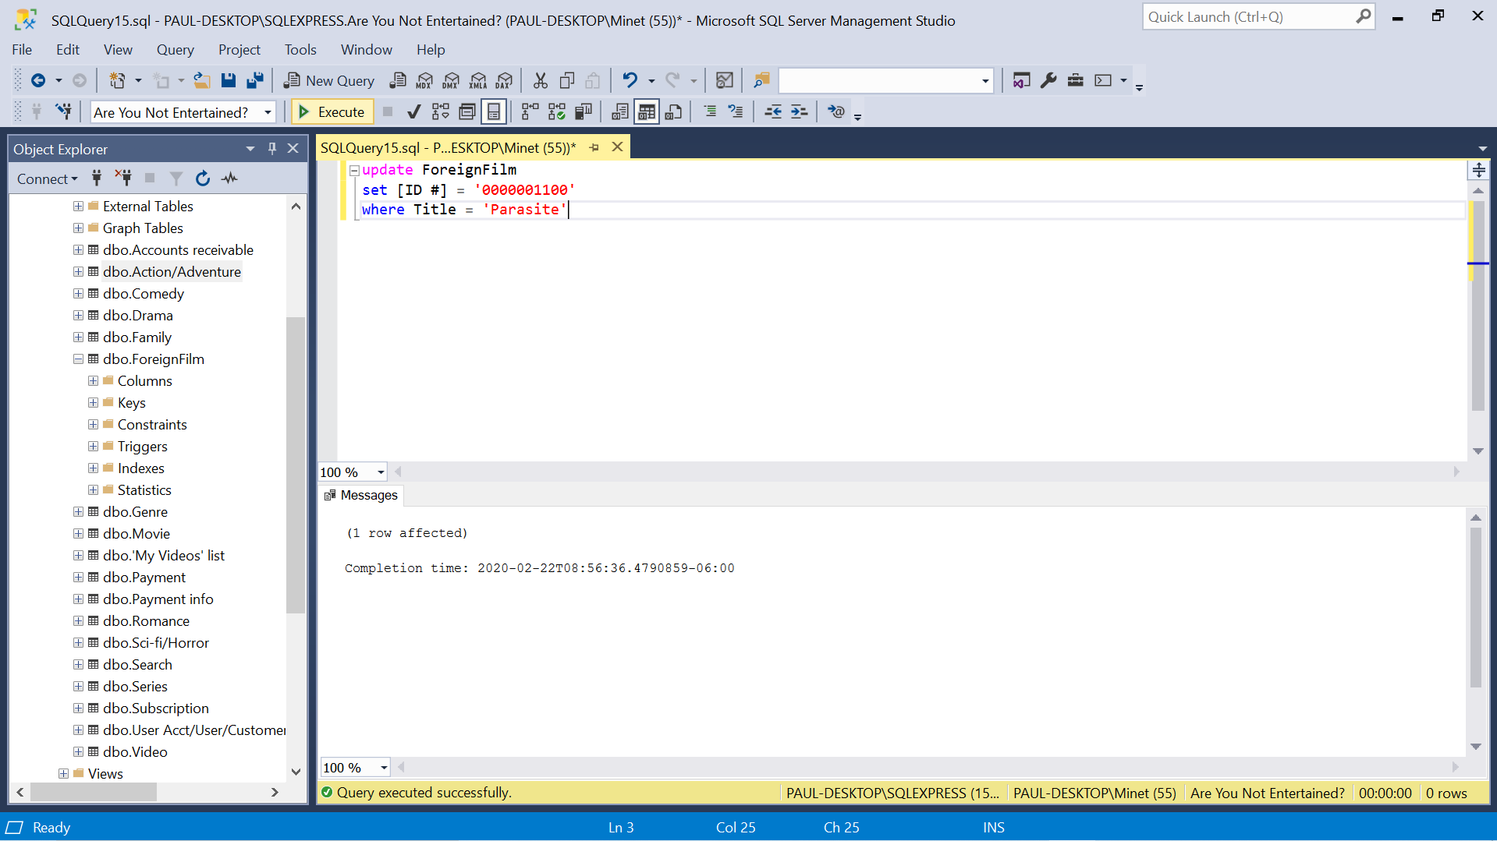

Update 1 row result

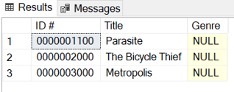

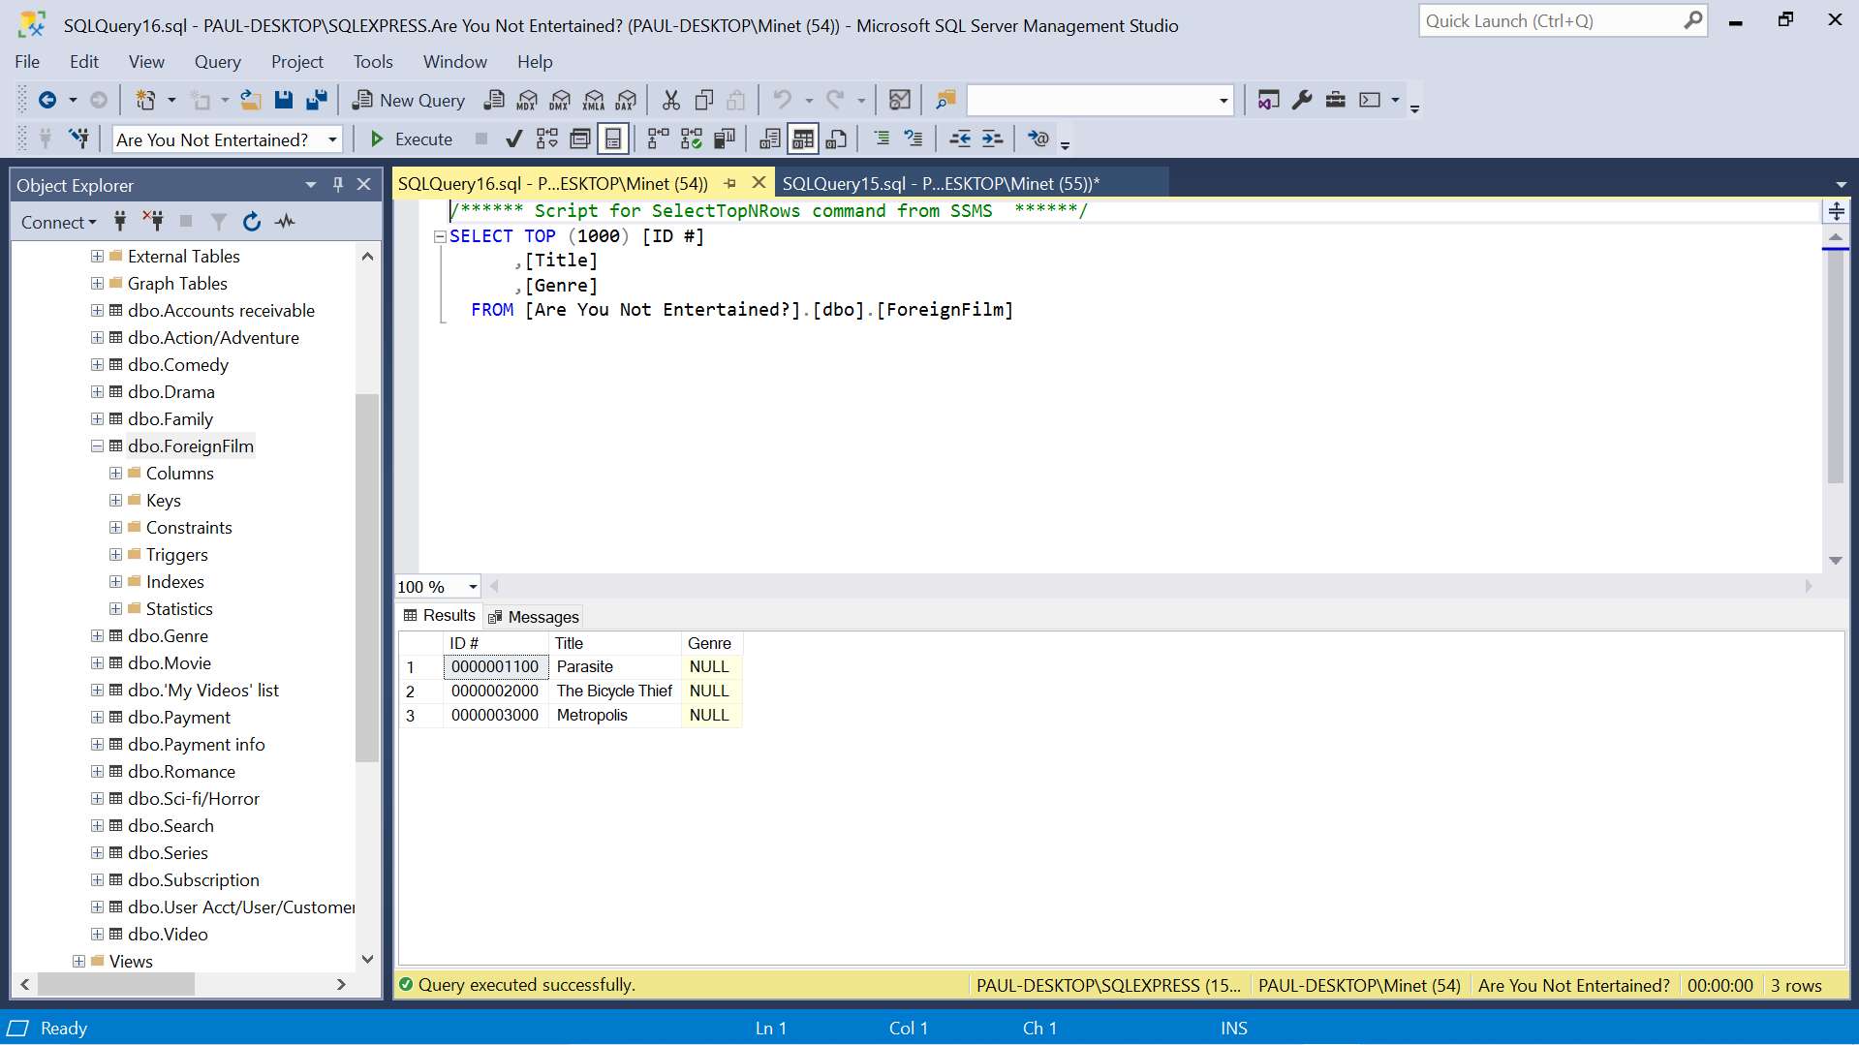

1. Table – Search

Insert 3 rows

Insert into Search ([Unstructured text], [User acct/User/Customer])

Values (‘Titanic’, ‘1’), (‘E.T.’, ‘2’), (‘Wizard of Oz’, ‘3’)

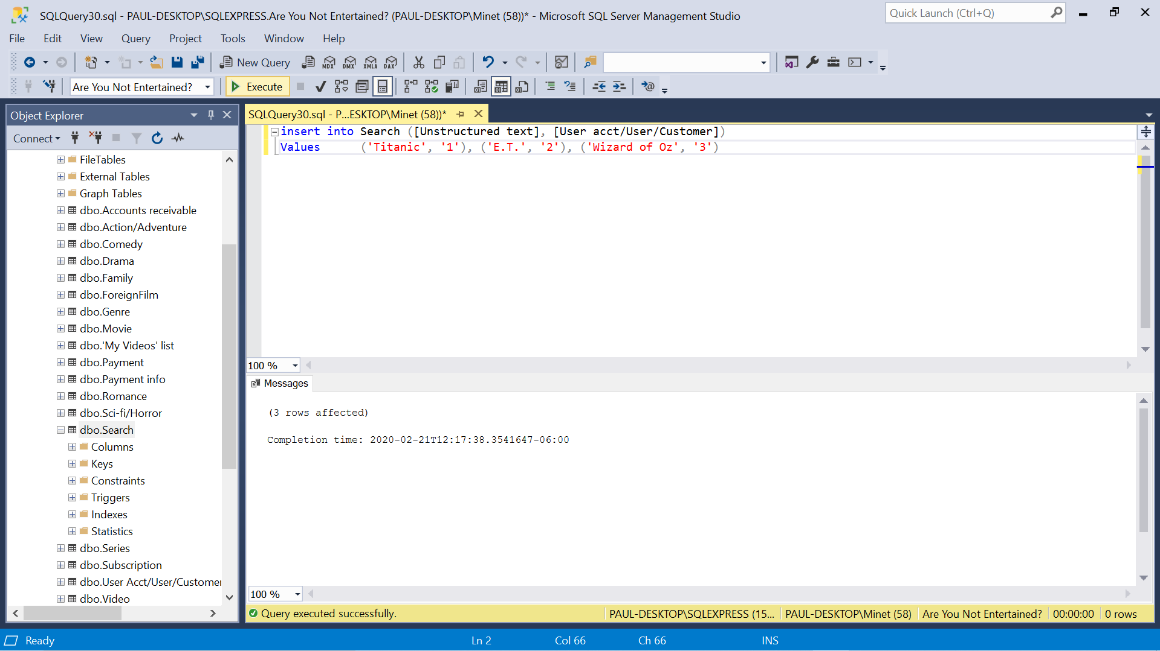

Insert 3 rows result

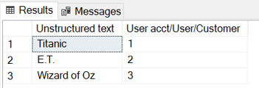

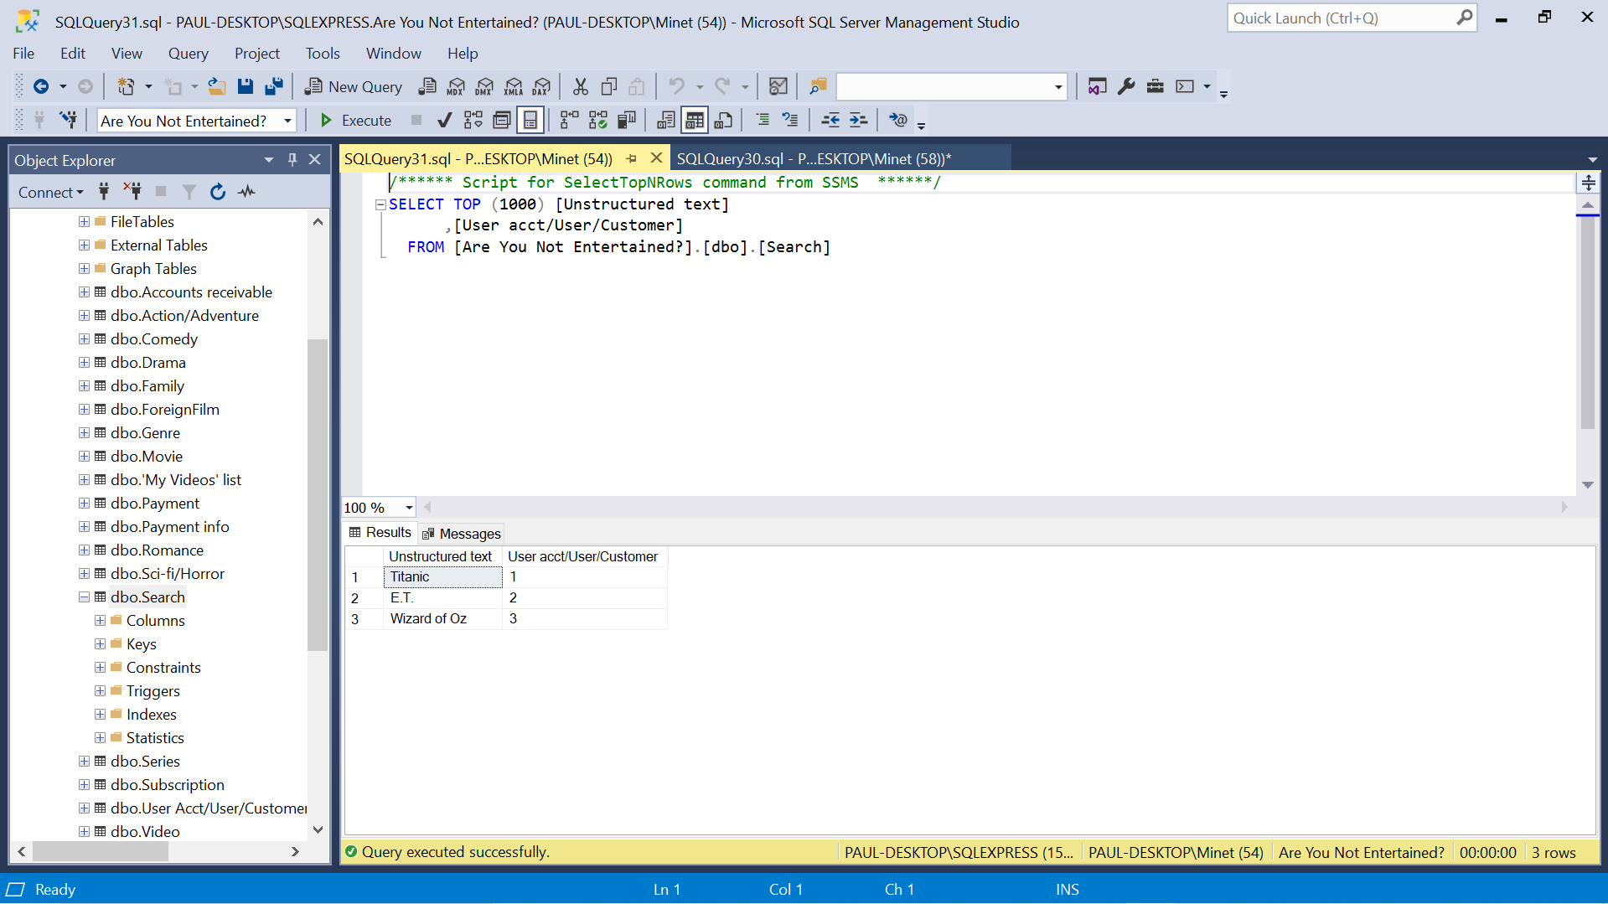

Update 1 row

Update Search

Set [Unstructured text] = ‘E.T. The Extra Terrestrial’

Where [User Acct/User/Customer] = ‘1’

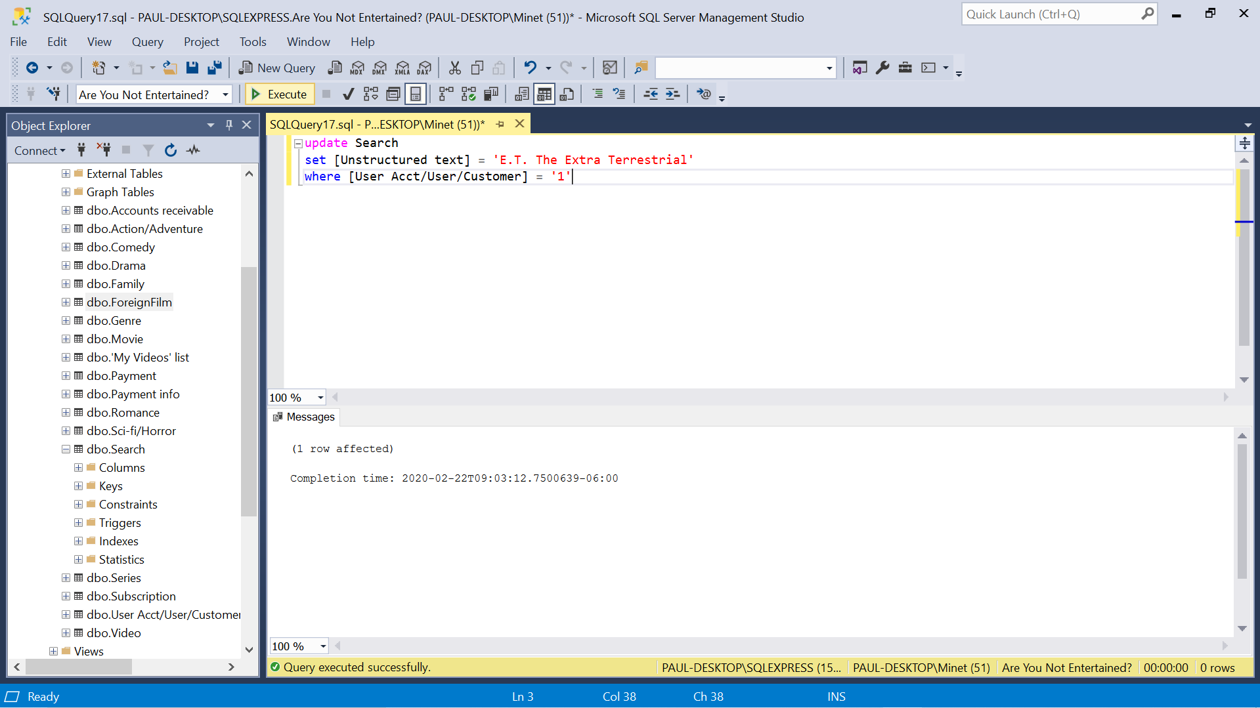

Update 1 row result

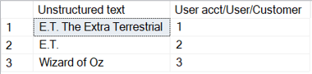

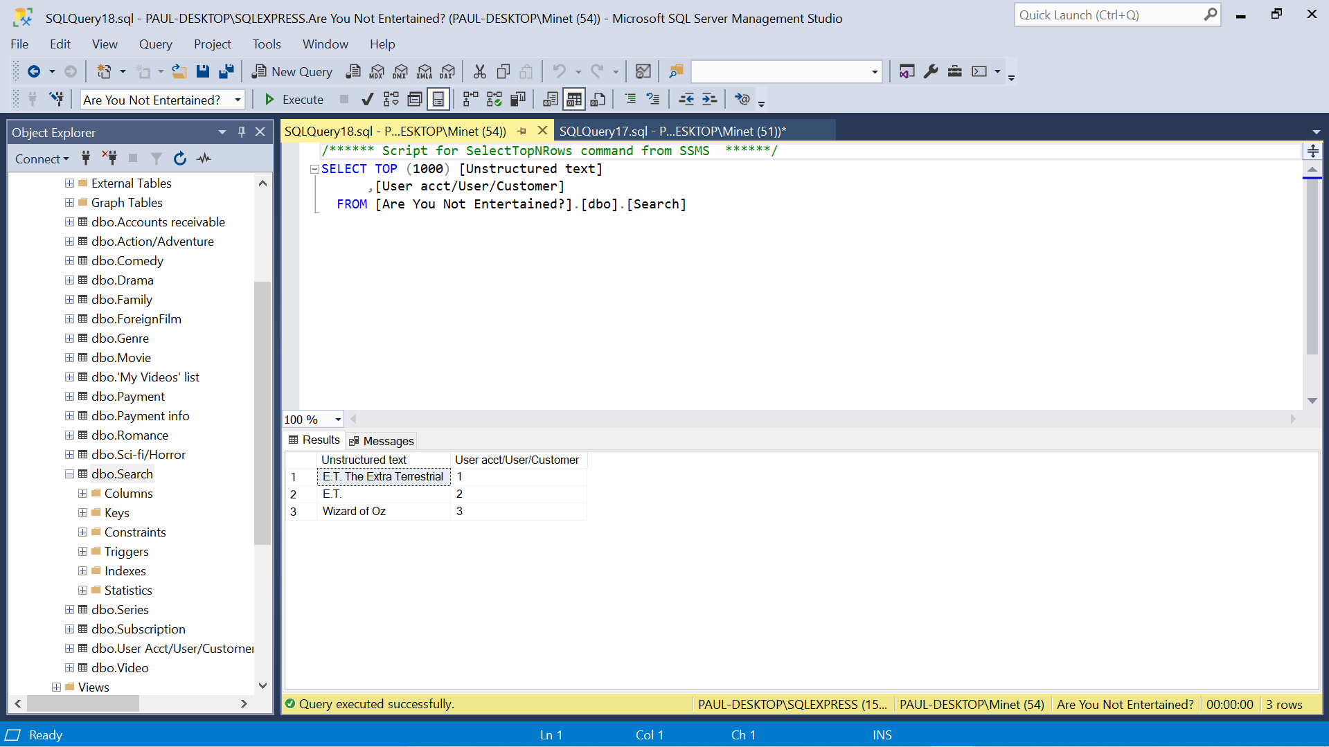

**8.** A summary of the challenges that you have faced in all the project phases.

Generally speaking, I found some of the explanations for simple concepts in the textbook to be overly complicated. Case in point for me was foreign keys. Building the actual database was pretty straightforward until I had to figure out how to connect the tables and how to apply the foreign key concept. I had to do a lot of my own research to find out what they were and how to use them. It was simple once I did. Initially drawing the ER diagram was extremely time consuming, even with the software I wound up using, Visio, which was one of the easiest to use. Also, drawing the tables in word with their connections was tedious to place all the lines by hand. Even with the software I was using with its preloads of objects for the ER diagram, it did not have all the necessary objects for the EER diagram, and I had to improvise a little using text boxes and repurposing and resizing other objects.

Part II: Writing Assignment

Front end is the part of an application or website that a user interacts with, know as the client-side. It contains elements such as a command line and GUI interface with buttons, drop-down and check boxes, tables, text boxes, images, graphs, etc. Basically, everything a user would need to make the experience of adding, retrieving, or manipulating data and functionality as easy and efficient as possible. Front end languages used on websites are usually HTML, the fundamental language for creating a website; CSS, (Cascading Style Sheets) a language that works with HTML that helps with the design; and JavaScript, which is used for elements like drop down menus, modal windows, and contact forms.

Front end jobs mostly consist of web designers, user interface (UI) designers, user experience (UX) designers, and front-end developers.

The back end is the server side where the data is physically stored, designed, and maintained. Some of the more common languages used for this is PHP, C++, Java, Python, and JavaScript. Users do not typically interact with the backend of a system. It consists of databases and servers.

Back end jobs are called back-end programmers and back-end developers and are concerned with security, structure, and content management.

**Sources**

<https://www.geeksforgeeks.org/frontend-vs-backend/>

<https://www.pluralsight.com/blog/film-games/whats-difference-front-end-back-end>

<https://careerfoundry.com/en/blog/web-development/whats-the-difference-between-frontend-and-backend/>